Cable Trays & Struts

**Cable Trays & Struts**

* [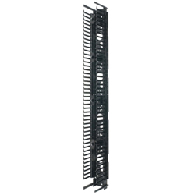](https://www.jhlarson.com/index.jsp?ID=/Cable-Trays-Struts/Cable-Management-Panels/dept-4SD&path=to&ds=dept)

[**Cable Management Panels (+)**](https://www.jhlarson.com/index.jsp?ID=/Cable-Trays-Struts/Cable-Management-Panels/dept-4SD&path=to&ds=dept)

* + [**Cable Management Panel Rings**](https://www.jhlarson.com/index.jsp?ID=/Cable-Trays-Struts/Cable-Management-Panels/Cable-Management-Panel-Rings/dept-4SE&path=find&ds=dept&a=1)

* [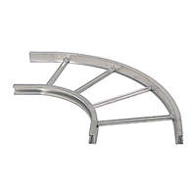](https://www.jhlarson.com/index.jsp?ID=/Cable-Trays-Struts/Cable-Tray-Accessories/dept-4SF&path=to&ds=dept)

[**Cable Tray Accessories (+)**](https://www.jhlarson.com/index.jsp?ID=/Cable-Trays-Struts/Cable-Tray-Accessories/dept-4SF&path=to&ds=dept)

* + [**Tray Barrier Strips**](https://www.jhlarson.com/index.jsp?ID=/Cable-Trays-Struts/Cable-Tray-Accessories/Tray-Barrier-Strips/dept-85D&path=find&ds=dept&a=1)

* + [**Tray Clamps**](https://www.jhlarson.com/index.jsp?ID=/Cable-Trays-Struts/Cable-Tray-Accessories/Tray-Clamps/dept-85A&path=find&ds=dept&a=1)

* + [**Tray Hold Down Clips**](https://www.jhlarson.com/index.jsp?ID=/Cable-Trays-Struts/Cable-Tray-Accessories/Tray-Hold-Down-Clips/dept-4SG&path=find&ds=dept&a=1)

* [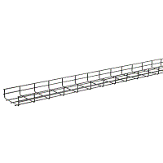](https://www.jhlarson.com/index.jsp?ID=/Cable-Trays-Struts/Cable-Trays/dept-4SH&path=to&ds=dept)

[**Cable Trays (+)**](https://www.jhlarson.com/index.jsp?ID=/Cable-Trays-Struts/Cable-Trays/dept-4SH&path=to&ds=dept)

* + [**Wire Mesh Cable Trays**](https://www.jhlarson.com/index.jsp?ID=/Cable-Trays-Struts/Cable-Trays/Wire-Mesh-Cable-Trays/dept-4SI&path=find&ds=dept&a=1)

* [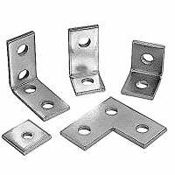](https://www.jhlarson.com/index.jsp?ID=/Cable-Trays-Struts/Strut-Channels-Accessories/dept-4SJ&path=to&ds=dept)

[**Strut Channels & Accessories (+)**](https://www.jhlarson.com/index.jsp?ID=/Cable-Trays-Struts/Strut-Channels-Accessories/dept-4SJ&path=to&ds=dept)

* + [**Channel 90-Deg Angle Fittings**](https://www.jhlarson.com/index.jsp?ID=/Cable-Trays-Struts/Strut-Channels-Accessories/Channel-90-Deg-Angle-Fittings/dept-4SK&path=find&ds=dept&a=1)

* + [**Channel Angular Fittings**](https://www.jhlarson.com/index.jsp?ID=/Cable-Trays-Struts/Strut-Channels-Accessories/Channel-Angular-Fittings/dept-4SL&path=find&ds=dept&a=1)

* + [**Channel Brackets & Braces**](https://www.jhlarson.com/index.jsp?ID=/Cable-Trays-Struts/Strut-Channels-Accessories/Channel-Brackets-Braces/dept-4SM&path=find&ds=dept&a=1)

* + [**Channel Closure Strip & Concrete Inserts**](https://www.jhlarson.com/index.jsp?ID=/Cable-Trays-Struts/Strut-Channels-Accessories/Channel-Closure-Strip-Concrete-Inserts/dept-72K&path=find&ds=dept&a=1)

* + [**Channel Column Support Plates**](https://www.jhlarson.com/index.jsp?ID=/Cable-Trays-Struts/Strut-Channels-Accessories/Channel-Column-Support-Plates/dept-72H&path=find&ds=dept&a=1)

* + [**Channel Connectors**](https://www.jhlarson.com/index.jsp?ID=/Cable-Trays-Struts/Strut-Channels-Accessories/Channel-Connectors/dept-85K&path=find&ds=dept&a=1)

* + [**Channel End Caps**](https://www.jhlarson.com/index.jsp?ID=/Cable-Trays-Struts/Strut-Channels-Accessories/Channel-End-Caps/dept-72B&path=find&ds=dept&a=1)

* + [**Channel Flat Plate Fittings**](https://www.jhlarson.com/index.jsp?ID=/Cable-Trays-Struts/Strut-Channels-Accessories/Channel-Flat-Plate-Fittings/dept-4SN&path=find&ds=dept&a=1)

* + [**Channel Hangers**](https://www.jhlarson.com/index.jsp?ID=/Cable-Trays-Struts/Strut-Channels-Accessories/Channel-Hangers/dept-72E&path=find&ds=dept&a=1)

* + [**Channel Joiners**](https://www.jhlarson.com/index.jsp?ID=/Cable-Trays-Struts/Strut-Channels-Accessories/Channel-Joiners/dept-4SO&path=find&ds=dept&a=1)

* + [**Channel Miscellaneous Accessories**](https://www.jhlarson.com/index.jsp?ID=/Cable-Trays-Struts/Strut-Channels-Accessories/Channel-Miscellaneous-Accessories/dept-4SP&path=find&ds=dept&a=1)

* + [**Channel Nuts & Hardware**](https://www.jhlarson.com/index.jsp?ID=/Cable-Trays-Struts/Strut-Channels-Accessories/Channel-Nuts-Hardware/dept-4SQ&path=find&ds=dept&a=1)

* + [**Channel Outlet Boxes**](https://www.jhlarson.com/index.jsp?ID=/Cable-Trays-Struts/Strut-Channels-Accessories/Channel-Outlet-Boxes/dept-72N&path=find&ds=dept&a=1)

* + [**Channel Post Bases**](https://www.jhlarson.com/index.jsp?ID=/Cable-Trays-Struts/Strut-Channels-Accessories/Channel-Post-Bases/dept-4SR&path=find&ds=dept&a=1)

* + [**Channel Rollers & Trolleys**](https://www.jhlarson.com/index.jsp?ID=/Cable-Trays-Struts/Strut-Channels-Accessories/Channel-Rollers-Trolleys/dept-72J&path=find&ds=dept&a=1)

* + [**Channel Splice Clevises**](https://www.jhlarson.com/index.jsp?ID=/Cable-Trays-Struts/Strut-Channels-Accessories/Channel-Splice-Clevises/dept-72D&path=find&ds=dept&a=1)

* + [**Channel Supports**](https://www.jhlarson.com/index.jsp?ID=/Cable-Trays-Struts/Strut-Channels-Accessories/Channel-Supports/dept-4SS&path=find&ds=dept&a=1)

* + [**Channel Washers**](https://www.jhlarson.com/index.jsp?ID=/Cable-Trays-Struts/Strut-Channels-Accessories/Channel-Washers/dept-4ST&path=find&ds=dept&a=1)

* + [**Channel Wing-Shaped Fittings**](https://www.jhlarson.com/index.jsp?ID=/Cable-Trays-Struts/Strut-Channels-Accessories/Channel-Wing-Shaped-Fittings/dept-72C&path=find&ds=dept&a=1)

* + [**Channel Z-Shaped Fittings**](https://www.jhlarson.com/index.jsp?ID=/Cable-Trays-Struts/Strut-Channels-Accessories/Channel-Z-Shaped-Fittings/dept-72F&path=find&ds=dept&a=1)

* + [**Channels**](https://www.jhlarson.com/index.jsp?ID=/Cable-Trays-Struts/Strut-Channels-Accessories/Channels/dept-4SU&path=find&ds=dept&a=1)

* [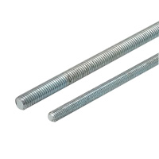](https://www.jhlarson.com/index.jsp?ID=/Cable-Trays-Struts/Threaded-Rods-Accessories/dept-4SV&path=to&ds=dept)

[**Threaded Rods & Accessories (+)**](https://www.jhlarson.com/index.jsp?ID=/Cable-Trays-Struts/Threaded-Rods-Accessories/dept-4SV&path=to&ds=dept)

* + [**Cable Tray & Strut Threaded Rods**](https://www.jhlarson.com/index.jsp?ID=/Cable-Trays-Struts/Threaded-Rods-Accessories/Cable-Tray-Strut-Threaded-Rods/dept-72O&path=find&ds=dept&a=1)

* + [**Pipe Spikes**](https://www.jhlarson.com/index.jsp?ID=/Cable-Trays-Struts/Threaded-Rods-Accessories/Pipe-Spikes/dept-72Q&path=find&ds=dept&a=1)

* + [**Threaded Rod Couplings**](https://www.jhlarson.com/index.jsp?ID=/Cable-Trays-Struts/Threaded-Rods-Accessories/Threaded-Rod-Couplings/dept-4SW&path=find&ds=dept&a=1)

**Air Distribution**

* [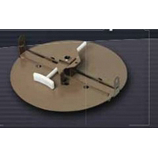](https://www.jhlarson.com/index.jsp?ID=/Air-Distribution/Dampers/dept-4NP&path=to&ds=dept)

[**Dampers (+)**](https://www.jhlarson.com/index.jsp?ID=/Air-Distribution/Dampers/dept-4NP&path=to&ds=dept)

* + [**Backdraft Dampers**](https://www.jhlarson.com/index.jsp?ID=/Air-Distribution/Dampers/Backdraft-Dampers/dept-4NQ&path=find&ds=dept&a=1)

* + [**Damper Accessories**](https://www.jhlarson.com/index.jsp?ID=/Air-Distribution/Dampers/Damper-Accessories/dept-4NR&path=find&ds=dept&a=1)

* + [**Duct Dampers**](https://www.jhlarson.com/index.jsp?ID=/Air-Distribution/Dampers/Duct-Dampers/dept-4NS&path=find&ds=dept&a=1)

* + [**Motorized Dampers**](https://www.jhlarson.com/index.jsp?ID=/Air-Distribution/Dampers/Motorized-Dampers/dept-4NT&path=find&ds=dept&a=1)

* + [**Specialty Dampers**](https://www.jhlarson.com/index.jsp?ID=/Air-Distribution/Dampers/Specialty-Dampers/dept-4NV&path=find&ds=dept&a=1)

* + [**Volume Control Dampers**](https://www.jhlarson.com/index.jsp?ID=/Air-Distribution/Dampers/Volume-Control-Dampers/dept-6SE&path=find&ds=dept&a=1)

* [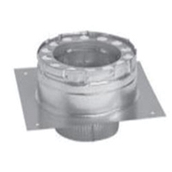](https://www.jhlarson.com/index.jsp?ID=/Air-Distribution/Ducting/dept-4NW&path=to&ds=dept)

[**Ducting (+)**](https://www.jhlarson.com/index.jsp?ID=/Air-Distribution/Ducting/dept-4NW&path=to&ds=dept)

* + [**Duct Accessories**](https://www.jhlarson.com/index.jsp?ID=/Air-Distribution/Ducting/Duct-Accessories/dept-4NX&path=to&ds=dept)

* + [**Duct Fittings**](https://www.jhlarson.com/index.jsp?ID=/Air-Distribution/Ducting/Duct-Fittings/dept-4O3&path=to&ds=dept)

* + [**Duct Plenums**](https://www.jhlarson.com/index.jsp?ID=/Air-Distribution/Ducting/Duct-Plenums/dept-6SJ&path=find&ds=dept&a=1)

* + [**Flexible Ducts**](https://www.jhlarson.com/index.jsp?ID=/Air-Distribution/Ducting/Flexible-Ducts/dept-6SI&path=find&ds=dept&a=1)

* + [**Oval Ducts**](https://www.jhlarson.com/index.jsp?ID=/Air-Distribution/Ducting/Oval-Ducts/dept-6SL&path=find&ds=dept&a=1)

* + [**Return Air Products**](https://www.jhlarson.com/index.jsp?ID=/Air-Distribution/Ducting/Return-Air-Products/dept-4OK&path=to&ds=dept)

* + [**Rectangular Ducts**](https://www.jhlarson.com/index.jsp?ID=/Air-Distribution/Ducting/Rectangular-Ducts/dept-6SG&path=find&ds=dept&a=1)

* + [**Round Ducts**](https://www.jhlarson.com/index.jsp?ID=/Air-Distribution/Ducting/Round-Ducts/dept-6SH&path=find&ds=dept&a=1)

* + [**Stack Ducts**](https://www.jhlarson.com/index.jsp?ID=/Air-Distribution/Ducting/Stack-Ducts/dept-6SK&path=find&ds=dept&a=1)

* [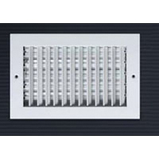](https://www.jhlarson.com/index.jsp?ID=/Air-Distribution/Grilles-Registers-Diffusers/dept-4ON&path=to&ds=dept)

[**Grilles, Registers & Diffusers (+)**](https://www.jhlarson.com/index.jsp?ID=/Air-Distribution/Grilles-Registers-Diffusers/dept-4ON&path=to&ds=dept)

* + [**Ceiling & Register Boxes & Outlets**](https://www.jhlarson.com/index.jsp?ID=/Air-Distribution/Grilles-Registers-Diffusers/Ceiling-Register-Boxes-Outlets/dept-4OO&path=to&ds=dept)

* + [**Diffusers**](https://www.jhlarson.com/index.jsp?ID=/Air-Distribution/Grilles-Registers-Diffusers/Diffusers/dept-4OR&path=to&ds=dept)

* + [**Grilles**](https://www.jhlarson.com/index.jsp?ID=/Air-Distribution/Grilles-Registers-Diffusers/Grilles/dept-4OW&path=to&ds=dept)

* + [**Registers**](https://www.jhlarson.com/index.jsp?ID=/Air-Distribution/Grilles-Registers-Diffusers/Registers/dept-4P4&path=to&ds=dept)

**DataComm/TeleComm**

* [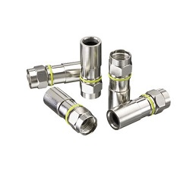](https://www.jhlarson.com/index.jsp?ID=/DataComm-TeleComm/Coaxial-Connectors-Plugs/dept-4WR&path=to&ds=dept)

[**Coaxial Connectors & Plugs (+)**](https://www.jhlarson.com/index.jsp?ID=/DataComm-TeleComm/Coaxial-Connectors-Plugs/dept-4WR&path=to&ds=dept)

* + [**Coaxial Connectors**](https://www.jhlarson.com/index.jsp?ID=/DataComm-TeleComm/Coaxial-Connectors-Plugs/Coaxial-Connectors/dept-4WS&path=find&ds=dept&a=1)

* + [**Coaxial Splitters**](https://www.jhlarson.com/index.jsp?ID=/DataComm-TeleComm/Coaxial-Connectors-Plugs/Coaxial-Splitters/dept-4WT&path=find&ds=dept&a=1)

* [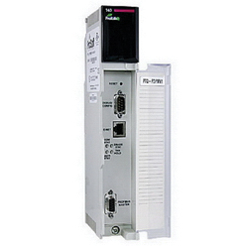](https://www.jhlarson.com/index.jsp?ID=/DataComm-TeleComm/Communications-Networking-Modules/dept-4WU&path=to&ds=dept)

[**Communications & Networking Modules (+)**](https://www.jhlarson.com/index.jsp?ID=/DataComm-TeleComm/Communications-Networking-Modules/dept-4WU&path=to&ds=dept)

* [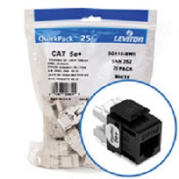](https://www.jhlarson.com/index.jsp?ID=/DataComm-TeleComm/Copper-Fiber-Modular-Inserts/dept-4WW&path=to&ds=dept)

[**Copper & Fiber Modular Inserts (+)**](https://www.jhlarson.com/index.jsp?ID=/DataComm-TeleComm/Copper-Fiber-Modular-Inserts/dept-4WW&path=to&ds=dept)

* + [**Blank Inserts**](https://www.jhlarson.com/index.jsp?ID=/DataComm-TeleComm/Copper-Fiber-Modular-Inserts/Blank-Inserts/dept-4WX&path=find&ds=dept&a=1)

* + [**Keystone Modules**](https://www.jhlarson.com/index.jsp?ID=/DataComm-TeleComm/Copper-Fiber-Modular-Inserts/Keystone-Modules/dept-4WY&path=find&ds=dept&a=1)

* + [**USB Inserts**](https://www.jhlarson.com/index.jsp?ID=/DataComm-TeleComm/Copper-Fiber-Modular-Inserts/USB-Inserts/dept-73D&path=find&ds=dept&a=1)

* + [**UTP Jack Inserts**](https://www.jhlarson.com/index.jsp?ID=/DataComm-TeleComm/Copper-Fiber-Modular-Inserts/UTP-Jack-Inserts/dept-4WZ&path=find&ds=dept&a=1)

* [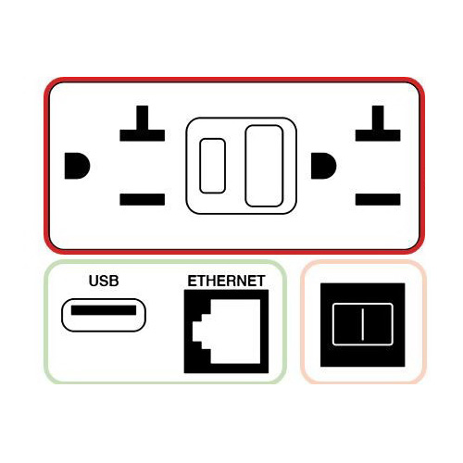](https://www.jhlarson.com/index.jsp?ID=/DataComm-TeleComm/Copper-Connectors-Plugs/dept-73E&path=to&ds=dept)

[**Copper Connectors & Plugs (+)**](https://www.jhlarson.com/index.jsp?ID=/DataComm-TeleComm/Copper-Connectors-Plugs/dept-73E&path=to&ds=dept)

* + [**Copper Connector Boots**](https://www.jhlarson.com/index.jsp?ID=/DataComm-TeleComm/Copper-Connectors-Plugs/Copper-Connector-Boots/dept-73H&path=find&ds=dept&a=1)

* + [**Copper Connectors**](https://www.jhlarson.com/index.jsp?ID=/DataComm-TeleComm/Copper-Connectors-Plugs/Copper-Connectors/dept-73G&path=find&ds=dept&a=1)

* [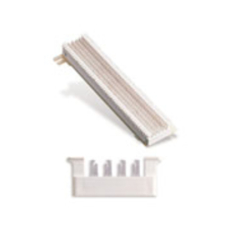](https://www.jhlarson.com/index.jsp?ID=/DataComm-TeleComm/Cross-Connecting-Blocks/dept-4X0&path=to&ds=dept)

[**Cross Connecting Blocks (+)**](https://www.jhlarson.com/index.jsp?ID=/DataComm-TeleComm/Cross-Connecting-Blocks/dept-4X0&path=to&ds=dept)

* + [**Connecting Block Patch Connectors**](https://www.jhlarson.com/index.jsp?ID=/DataComm-TeleComm/Cross-Connecting-Blocks/Connecting-Block-Patch-Connectors/dept-4X1&path=find&ds=dept&a=1)

* [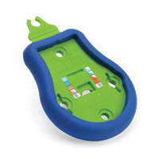](https://www.jhlarson.com/index.jsp?ID=/DataComm-TeleComm/Development-Boards-Evaluation-Kits/dept-73J&path=to&ds=dept)

[**Development Boards & Evaluation Kits (+)**](https://www.jhlarson.com/index.jsp?ID=/DataComm-TeleComm/Development-Boards-Evaluation-Kits/dept-73J&path=to&ds=dept)

* + [**Lighting Development Tools**](https://www.jhlarson.com/index.jsp?ID=/DataComm-TeleComm/Development-Boards-Evaluation-Kits/Lighting-Development-Tools/dept-73K&path=find&ds=dept&a=1)

* [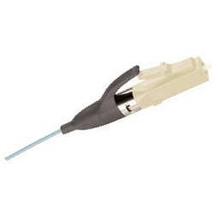](https://www.jhlarson.com/index.jsp?ID=/DataComm-TeleComm/Fiber-Optic-Termination-Splicing/dept-4X2&path=to&ds=dept)

[**Fiber Optic Termination & Splicing (+)**](https://www.jhlarson.com/index.jsp?ID=/DataComm-TeleComm/Fiber-Optic-Termination-Splicing/dept-4X2&path=to&ds=dept)

* [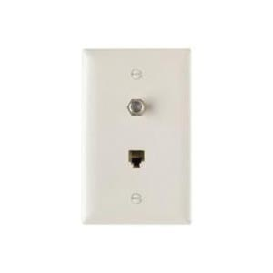](https://www.jhlarson.com/index.jsp?ID=/DataComm-TeleComm/Modular-Outlets-Faceplates/dept-4X4&path=to&ds=dept)

[**Modular Outlets & Faceplates (+)**](https://www.jhlarson.com/index.jsp?ID=/DataComm-TeleComm/Modular-Outlets-Faceplates/dept-4X4&path=to&ds=dept)

* + [**Coaxial Outlets**](https://www.jhlarson.com/index.jsp?ID=/DataComm-TeleComm/Modular-Outlets-Faceplates/Coaxial-Outlets/dept-4X5&path=find&ds=dept&a=1)

* + [**Combination Outlets**](https://www.jhlarson.com/index.jsp?ID=/DataComm-TeleComm/Modular-Outlets-Faceplates/Combination-Outlets/dept-4X6&path=find&ds=dept&a=1)

* + [**Faceplate Adapter Frames**](https://www.jhlarson.com/index.jsp?ID=/DataComm-TeleComm/Modular-Outlets-Faceplates/Faceplate-Adapter-Frames/dept-4X7&path=find&ds=dept&a=1)

* + [**Faceplate Modular Adapter Inserts**](https://www.jhlarson.com/index.jsp?ID=/DataComm-TeleComm/Modular-Outlets-Faceplates/Faceplate-Modular-Adapter-Inserts/dept-4X8&path=find&ds=dept&a=1)

* + [**Multimedia-Modular Jack Faceplates**](https://www.jhlarson.com/index.jsp?ID=/DataComm-TeleComm/Modular-Outlets-Faceplates/Multimedia-Modular-Jack-Faceplates/dept-4X9&path=find&ds=dept&a=1)

* + [**Outlet Mounting Brackets**](https://www.jhlarson.com/index.jsp?ID=/DataComm-TeleComm/Modular-Outlets-Faceplates/Outlet-Mounting-Brackets/dept-4XB&path=find&ds=dept&a=1)

* + [**Surface Outlet Box**](https://www.jhlarson.com/index.jsp?ID=/DataComm-TeleComm/Modular-Outlets-Faceplates/Surface-Outlet-Box/dept-746&path=find&ds=dept&a=1)

* + [**UTP Outlets**](https://www.jhlarson.com/index.jsp?ID=/DataComm-TeleComm/Modular-Outlets-Faceplates/UTP-Outlets/dept-4XC&path=find&ds=dept&a=1)

* [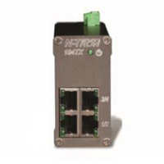](https://www.jhlarson.com/index.jsp?ID=/DataComm-TeleComm/Network-Hardware-Media-Converters/dept-4XD&path=to&ds=dept)

[**Network Hardware - Media Converters (+)**](https://www.jhlarson.com/index.jsp?ID=/DataComm-TeleComm/Network-Hardware-Media-Converters/dept-4XD&path=to&ds=dept)

* + [**Miscellaneous Ethernet Modules**](https://www.jhlarson.com/index.jsp?ID=/DataComm-TeleComm/Network-Hardware-Media-Converters/Miscellaneous-Ethernet-Modules/dept-747&path=find&ds=dept&a=1)

* + [**Network Repeaters**](https://www.jhlarson.com/index.jsp?ID=/DataComm-TeleComm/Network-Hardware-Media-Converters/Network-Repeaters/dept-4XE&path=find&ds=dept&a=1)

* + [**Network Routers & Bridges**](https://www.jhlarson.com/index.jsp?ID=/DataComm-TeleComm/Network-Hardware-Media-Converters/Network-Routers-Bridges/dept-74E&path=find&ds=dept&a=1)

* + [**Network Switches**](https://www.jhlarson.com/index.jsp?ID=/DataComm-TeleComm/Network-Hardware-Media-Converters/Network-Switches/dept-4XF&path=find&ds=dept&a=1)

* + [**Wireless I/O Modules**](https://www.jhlarson.com/index.jsp?ID=/DataComm-TeleComm/Network-Hardware-Media-Converters/Wireless-I-O-Modules/dept-74F&path=find&ds=dept&a=1)

* + [**Wireless Transmitters & Receivers**](https://www.jhlarson.com/index.jsp?ID=/DataComm-TeleComm/Network-Hardware-Media-Converters/Wireless-Transmitters-Receivers/dept-74K&path=find&ds=dept&a=1)

* [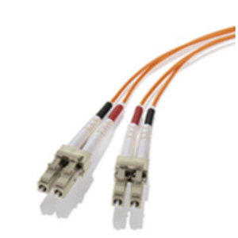](https://www.jhlarson.com/index.jsp?ID=/DataComm-TeleComm/Patch-Cords/dept-4XG&path=to&ds=dept)

[**Patch Cords (+)**](https://www.jhlarson.com/index.jsp?ID=/DataComm-TeleComm/Patch-Cords/dept-4XG&path=to&ds=dept)

* + [**Communication Cables**](https://www.jhlarson.com/index.jsp?ID=/DataComm-TeleComm/Patch-Cords/Communication-Cables/dept-4XH&path=find&ds=dept&a=1)

* + [**Copper Patch Cords**](https://www.jhlarson.com/index.jsp?ID=/DataComm-TeleComm/Patch-Cords/Copper-Patch-Cords/dept-74M&path=find&ds=dept&a=1)

* + [**Fiber Optic Patch Cords**](https://www.jhlarson.com/index.jsp?ID=/DataComm-TeleComm/Patch-Cords/Fiber-Optic-Patch-Cords/dept-74N&path=find&ds=dept&a=1)

* [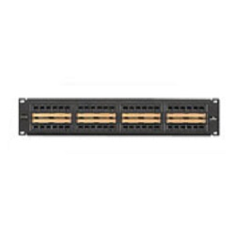](https://www.jhlarson.com/index.jsp?ID=/DataComm-TeleComm/Patch-Panels/dept-4XI&path=to&ds=dept)

[**Patch Panels (+)**](https://www.jhlarson.com/index.jsp?ID=/DataComm-TeleComm/Patch-Panels/dept-4XI&path=to&ds=dept)

* + [**CU Media Patch Panels - Loaded**](https://www.jhlarson.com/index.jsp?ID=/DataComm-TeleComm/Patch-Panels/CU-Media-Patch-Panels-Loaded/dept-4XJ&path=find&ds=dept&a=1)

* + [**Keystone Patch Panels**](https://www.jhlarson.com/index.jsp?ID=/DataComm-TeleComm/Patch-Panels/Keystone-Patch-Panels/dept-4XK&path=find&ds=dept&a=1)

* + [**Patch Panel Cable Brackets**](https://www.jhlarson.com/index.jsp?ID=/DataComm-TeleComm/Patch-Panels/Patch-Panel-Cable-Brackets/dept-4XL&path=find&ds=dept&a=1)

* [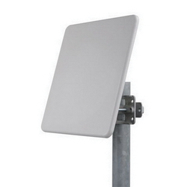](https://www.jhlarson.com/index.jsp?ID=/DataComm-TeleComm/RF-IF-RFID-Modules/dept-4XM&path=to&ds=dept)

[**RF/IF & RFID Modules (+)**](https://www.jhlarson.com/index.jsp?ID=/DataComm-TeleComm/RF-IF-RFID-Modules/dept-4XM&path=to&ds=dept)

* + [**RF Receivers**](https://www.jhlarson.com/index.jsp?ID=/DataComm-TeleComm/RF-IF-RFID-Modules/RF-Receivers/dept-4XN&path=find&ds=dept&a=1)

* + [**RF Transmitters**](https://www.jhlarson.com/index.jsp?ID=/DataComm-TeleComm/RF-IF-RFID-Modules/RF-Transmitters/dept-4XO&path=find&ds=dept&a=1)

* [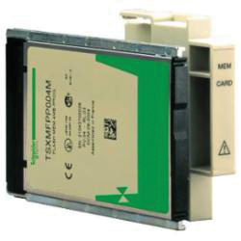](https://www.jhlarson.com/index.jsp?ID=/DataComm-TeleComm/System-Cards/dept-757&path=to&ds=dept)

[**System Cards (+)**](https://www.jhlarson.com/index.jsp?ID=/DataComm-TeleComm/System-Cards/dept-757&path=to&ds=dept)

* [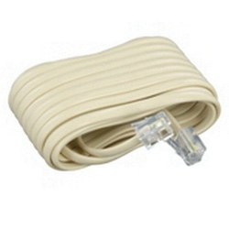](https://www.jhlarson.com/index.jsp?ID=/DataComm-TeleComm/Telephones-Voice-Communication/dept-4XP&path=to&ds=dept)

[**Telephones - Voice Communication (+)**](https://www.jhlarson.com/index.jsp?ID=/DataComm-TeleComm/Telephones-Voice-Communication/dept-4XP&path=to&ds=dept)

* + [**Telephone Accessories**](https://www.jhlarson.com/index.jsp?ID=/DataComm-TeleComm/Telephones-Voice-Communication/Telephone-Accessories/dept-75E&path=find&ds=dept&a=1)

* + [**Telephone Enclosures**](https://www.jhlarson.com/index.jsp?ID=/DataComm-TeleComm/Telephones-Voice-Communication/Telephone-Enclosures/dept-4XQ&path=find&ds=dept&a=1)

* + [**Telephone Line Sharing Devices**](https://www.jhlarson.com/index.jsp?ID=/DataComm-TeleComm/Telephones-Voice-Communication/Telephone-Line-Sharing-Devices/dept-4XR&path=find&ds=dept&a=1)

**Distribution Equipment & Accessories**

* [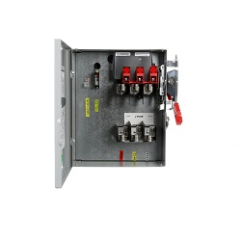](https://www.jhlarson.com/index.jsp?ID=/Distribution-Equipment-Accessories/Busways-Busway-Fittings-Accessories/dept-4XT&path=to&ds=dept)

[**Busways, Busway Fittings & Accessories (+)**](https://www.jhlarson.com/index.jsp?ID=/Distribution-Equipment-Accessories/Busways-Busway-Fittings-Accessories/dept-4XT&path=to&ds=dept)

* + [**Busway Accessories**](https://www.jhlarson.com/index.jsp?ID=/Distribution-Equipment-Accessories/Busways-Busway-Fittings-Accessories/Busway-Accessories/dept-4XU&path=find&ds=dept&a=1)

* + [**Busway Fusible Plug Units**](https://www.jhlarson.com/index.jsp?ID=/Distribution-Equipment-Accessories/Busways-Busway-Fittings-Accessories/Busway-Fusible-Plug-Units/dept-4XV&path=find&ds=dept&a=1)

* + [**Busway Tap Boxes**](https://www.jhlarson.com/index.jsp?ID=/Distribution-Equipment-Accessories/Busways-Busway-Fittings-Accessories/Busway-Tap-Boxes/dept-790&path=find&ds=dept&a=1)

* + [**Feeder Busbars**](https://www.jhlarson.com/index.jsp?ID=/Distribution-Equipment-Accessories/Busways-Busway-Fittings-Accessories/Feeder-Busbars/dept-4XW&path=find&ds=dept&a=1)

* [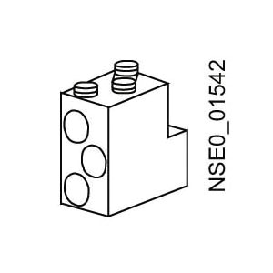](https://www.jhlarson.com/index.jsp?ID=/Distribution-Equipment-Accessories/Circuit-Breaker-Accessories/dept-4XX&path=to&ds=dept)

[**Circuit Breaker Accessories (+)**](https://www.jhlarson.com/index.jsp?ID=/Distribution-Equipment-Accessories/Circuit-Breaker-Accessories/dept-4XX&path=to&ds=dept)

* + [**Breaker Auxiliary Switches-Contacts**](https://www.jhlarson.com/index.jsp?ID=/Distribution-Equipment-Accessories/Circuit-Breaker-Accessories/Breaker-Auxiliary-Switches-Contacts/dept-4XY&path=find&ds=dept&a=1)

* + [**Breaker Enclosure Hubs**](https://www.jhlarson.com/index.jsp?ID=/Distribution-Equipment-Accessories/Circuit-Breaker-Accessories/Breaker-Enclosure-Hubs/dept-4XZ&path=find&ds=dept&a=1)

* + [**Breaker Enclosure Neutral Kits**](https://www.jhlarson.com/index.jsp?ID=/Distribution-Equipment-Accessories/Circuit-Breaker-Accessories/Breaker-Enclosure-Neutral-Kits/dept-4Y0&path=find&ds=dept&a=1)

* + [**Breaker Frames**](https://www.jhlarson.com/index.jsp?ID=/Distribution-Equipment-Accessories/Circuit-Breaker-Accessories/Breaker-Frames/dept-4Y1&path=find&ds=dept&a=1)

* + [**Breaker Handle Locks**](https://www.jhlarson.com/index.jsp?ID=/Distribution-Equipment-Accessories/Circuit-Breaker-Accessories/Breaker-Handle-Locks/dept-4Y2&path=find&ds=dept&a=1)

* + [**Breaker Handle Ties & Extensions**](https://www.jhlarson.com/index.jsp?ID=/Distribution-Equipment-Accessories/Circuit-Breaker-Accessories/Breaker-Handle-Ties-Extensions/dept-4Y3&path=find&ds=dept&a=1)

* + [**Breaker Hold Down Kits**](https://www.jhlarson.com/index.jsp?ID=/Distribution-Equipment-Accessories/Circuit-Breaker-Accessories/Breaker-Hold-Down-Kits/dept-4Y4&path=find&ds=dept&a=1)

* + [**Breaker Mechanical Interlocks**](https://www.jhlarson.com/index.jsp?ID=/Distribution-Equipment-Accessories/Circuit-Breaker-Accessories/Breaker-Mechanical-Interlocks/dept-4Y5&path=find&ds=dept&a=1)

* + [**Breaker Modification Kits**](https://www.jhlarson.com/index.jsp?ID=/Distribution-Equipment-Accessories/Circuit-Breaker-Accessories/Breaker-Modification-Kits/dept-88K&path=find&ds=dept&a=1)

* + [**Breaker Mounting Accessories**](https://www.jhlarson.com/index.jsp?ID=/Distribution-Equipment-Accessories/Circuit-Breaker-Accessories/Breaker-Mounting-Accessories/dept-4Y6&path=find&ds=dept&a=1)

* + [**Breaker Rating Plugs**](https://www.jhlarson.com/index.jsp?ID=/Distribution-Equipment-Accessories/Circuit-Breaker-Accessories/Breaker-Rating-Plugs/dept-4Y8&path=find&ds=dept&a=1)

* + [**Breaker Renewal Parts/Accessories**](https://www.jhlarson.com/index.jsp?ID=/Distribution-Equipment-Accessories/Circuit-Breaker-Accessories/Breaker-Renewal-Parts-Accessories/dept-4Y9&path=find&ds=dept&a=1)

* + [**Breaker Sealing Boots-Covers**](https://www.jhlarson.com/index.jsp?ID=/Distribution-Equipment-Accessories/Circuit-Breaker-Accessories/Breaker-Sealing-Boots-Covers/dept-4YA&path=find&ds=dept&a=1)

* + [**Breaker Shunt Trips**](https://www.jhlarson.com/index.jsp?ID=/Distribution-Equipment-Accessories/Circuit-Breaker-Accessories/Breaker-Shunt-Trips/dept-4YB&path=find&ds=dept&a=1)

* + [**Breaker Terminal Shields**](https://www.jhlarson.com/index.jsp?ID=/Distribution-Equipment-Accessories/Circuit-Breaker-Accessories/Breaker-Terminal-Shields/dept-4YC&path=find&ds=dept&a=1)

* + [**Breaker Terminals**](https://www.jhlarson.com/index.jsp?ID=/Distribution-Equipment-Accessories/Circuit-Breaker-Accessories/Breaker-Terminals/dept-4YD&path=find&ds=dept&a=1)

* + [**Breaker Trip Units**](https://www.jhlarson.com/index.jsp?ID=/Distribution-Equipment-Accessories/Circuit-Breaker-Accessories/Breaker-Trip-Units/dept-4YE&path=find&ds=dept&a=1)

* + [**Disconnect Flange Cables**](https://www.jhlarson.com/index.jsp?ID=/Distribution-Equipment-Accessories/Circuit-Breaker-Accessories/Disconnect-Flange-Cables/dept-88T&path=find&ds=dept&a=1)

* + [**Disconnect Operating Handles**](https://www.jhlarson.com/index.jsp?ID=/Distribution-Equipment-Accessories/Circuit-Breaker-Accessories/Disconnect-Operating-Handles/dept-4YG&path=find&ds=dept&a=1)

* + [**Disconnect Operating Mechanisms**](https://www.jhlarson.com/index.jsp?ID=/Distribution-Equipment-Accessories/Circuit-Breaker-Accessories/Disconnect-Operating-Mechanisms/dept-88U&path=find&ds=dept&a=1)

* + [**Ground Fault Attachments**](https://www.jhlarson.com/index.jsp?ID=/Distribution-Equipment-Accessories/Circuit-Breaker-Accessories/Ground-Fault-Attachments/dept-4YH&path=find&ds=dept&a=1)

* [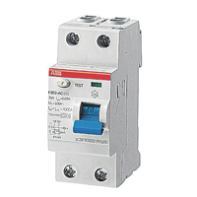](https://www.jhlarson.com/index.jsp?ID=/Distribution-Equipment-Accessories/Circuit-Breakers/dept-4YJ&path=to&ds=dept)

[**Circuit Breakers (+)**](https://www.jhlarson.com/index.jsp?ID=/Distribution-Equipment-Accessories/Circuit-Breakers/dept-4YJ&path=to&ds=dept)

* + [**Arc-Fault Circuit Breakers**](https://www.jhlarson.com/index.jsp?ID=/Distribution-Equipment-Accessories/Circuit-Breakers/Arc-Fault-Circuit-Breakers/dept-4YK&path=find&ds=dept&a=1)

* + [**Combination Circuit Breakers**](https://www.jhlarson.com/index.jsp?ID=/Distribution-Equipment-Accessories/Circuit-Breakers/Combination-Circuit-Breakers/dept-4YL&path=find&ds=dept&a=1)

* + [**Earth Leakage Circuit Breakers**](https://www.jhlarson.com/index.jsp?ID=/Distribution-Equipment-Accessories/Circuit-Breakers/Earth-Leakage-Circuit-Breakers/dept-890&path=find&ds=dept&a=1)

* + [**Ground-Fault Circuit Breakers**](https://www.jhlarson.com/index.jsp?ID=/Distribution-Equipment-Accessories/Circuit-Breakers/Ground-Fault-Circuit-Breakers/dept-4YM&path=find&ds=dept&a=1)

* + [**Lighting Panel Circuit Breakers**](https://www.jhlarson.com/index.jsp?ID=/Distribution-Equipment-Accessories/Circuit-Breakers/Lighting-Panel-Circuit-Breakers/dept-4YN&path=find&ds=dept&a=1)

* + [**Miniature Circuit Breakers**](https://www.jhlarson.com/index.jsp?ID=/Distribution-Equipment-Accessories/Circuit-Breakers/Miniature-Circuit-Breakers/dept-4YO&path=find&ds=dept&a=1)

* + [**Molded Case Circuit Breakers**](https://www.jhlarson.com/index.jsp?ID=/Distribution-Equipment-Accessories/Circuit-Breakers/Molded-Case-Circuit-Breakers/dept-4YP&path=find&ds=dept&a=1)

* + [**Motor Circuit Protectors**](https://www.jhlarson.com/index.jsp?ID=/Distribution-Equipment-Accessories/Circuit-Breakers/Motor-Circuit-Protectors/dept-4YQ&path=find&ds=dept&a=1)

* + [**Motor Protection Circuit Breakers**](https://www.jhlarson.com/index.jsp?ID=/Distribution-Equipment-Accessories/Circuit-Breakers/Motor-Protection-Circuit-Breakers/dept-4YR&path=find&ds=dept&a=1)

* + [**Special Application Breakers**](https://www.jhlarson.com/index.jsp?ID=/Distribution-Equipment-Accessories/Circuit-Breakers/Special-Application-Breakers/dept-4YS&path=find&ds=dept&a=1)

* + [**Standard Thermal Magnetic Circuit Breakers**](https://www.jhlarson.com/index.jsp?ID=/Distribution-Equipment-Accessories/Circuit-Breakers/Standard-Thermal-Magnetic-Circuit-Breakers/dept-4YT&path=find&ds=dept&a=1)

* + [**Supplementary Protectors**](https://www.jhlarson.com/index.jsp?ID=/Distribution-Equipment-Accessories/Circuit-Breakers/Supplementary-Protectors/dept-8A9&path=find&ds=dept&a=1)

* [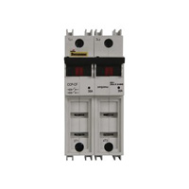](https://www.jhlarson.com/index.jsp?ID=/Distribution-Equipment-Accessories/Fused-Overcurrent-Protection-Modules/dept-894&path=to&ds=dept)

[**Fused Overcurrent Protection Modules (+)**](https://www.jhlarson.com/index.jsp?ID=/Distribution-Equipment-Accessories/Fused-Overcurrent-Protection-Modules/dept-894&path=to&ds=dept)

* [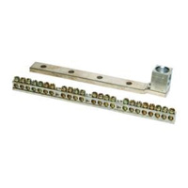](https://www.jhlarson.com/index.jsp?ID=/Distribution-Equipment-Accessories/Load-Center-Accessories/dept-4YU&path=to&ds=dept)

[**Load Center Accessories (+)**](https://www.jhlarson.com/index.jsp?ID=/Distribution-Equipment-Accessories/Load-Center-Accessories/dept-4YU&path=to&ds=dept)

* + [**Load Center Bonding Straps**](https://www.jhlarson.com/index.jsp?ID=/Distribution-Equipment-Accessories/Load-Center-Accessories/Load-Center-Bonding-Straps/dept-4YV&path=find&ds=dept&a=1)

* + [**Load Center Conversion Kits**](https://www.jhlarson.com/index.jsp?ID=/Distribution-Equipment-Accessories/Load-Center-Accessories/Load-Center-Conversion-Kits/dept-4YW&path=find&ds=dept&a=1)

* + [**Load Center Covers & Doors**](https://www.jhlarson.com/index.jsp?ID=/Distribution-Equipment-Accessories/Load-Center-Accessories/Load-Center-Covers-Doors/dept-4YX&path=find&ds=dept&a=1)

* + [**Load Center Door Locks & Latches**](https://www.jhlarson.com/index.jsp?ID=/Distribution-Equipment-Accessories/Load-Center-Accessories/Load-Center-Door-Locks-Latches/dept-4YY&path=find&ds=dept&a=1)

* + [**Load Center Enclosures**](https://www.jhlarson.com/index.jsp?ID=/Distribution-Equipment-Accessories/Load-Center-Accessories/Load-Center-Enclosures/dept-4YZ&path=find&ds=dept&a=1)

* + [**Load Center Filler Plates**](https://www.jhlarson.com/index.jsp?ID=/Distribution-Equipment-Accessories/Load-Center-Accessories/Load-Center-Filler-Plates/dept-4Z0&path=find&ds=dept&a=1)

* + [**Load Center Hubs & Covers**](https://www.jhlarson.com/index.jsp?ID=/Distribution-Equipment-Accessories/Load-Center-Accessories/Load-Center-Hubs-Covers/dept-4Z1&path=find&ds=dept&a=1)

* + [**Load Center Isolated Neutral Assembly**](https://www.jhlarson.com/index.jsp?ID=/Distribution-Equipment-Accessories/Load-Center-Accessories/Load-Center-Isolated-Neutral-Assembly/dept-4Z3&path=find&ds=dept&a=1)

* + [**Load Center Labels**](https://www.jhlarson.com/index.jsp?ID=/Distribution-Equipment-Accessories/Load-Center-Accessories/Load-Center-Labels/dept-4Z4&path=find&ds=dept&a=1)

* + [**Load Center Lugs**](https://www.jhlarson.com/index.jsp?ID=/Distribution-Equipment-Accessories/Load-Center-Accessories/Load-Center-Lugs/dept-4Z5&path=find&ds=dept&a=1)

* + [**Load Center Mechanical Interlock Covers**](https://www.jhlarson.com/index.jsp?ID=/Distribution-Equipment-Accessories/Load-Center-Accessories/Load-Center-Mechanical-Interlock-Covers/dept-4Z6&path=find&ds=dept&a=1)

* + [**Load Center Mechanical Interlocks**](https://www.jhlarson.com/index.jsp?ID=/Distribution-Equipment-Accessories/Load-Center-Accessories/Load-Center-Mechanical-Interlocks/dept-4Z7&path=find&ds=dept&a=1)

* + [**Load Center Miscellaneous Accessories**](https://www.jhlarson.com/index.jsp?ID=/Distribution-Equipment-Accessories/Load-Center-Accessories/Load-Center-Miscellaneous-Accessories/dept-4Z8&path=find&ds=dept&a=1)

* + [**Load Center Mounting Accessories**](https://www.jhlarson.com/index.jsp?ID=/Distribution-Equipment-Accessories/Load-Center-Accessories/Load-Center-Mounting-Accessories/dept-4Z9&path=find&ds=dept&a=1)

* + [**Load Center Neutral & Ground Bars**](https://www.jhlarson.com/index.jsp?ID=/Distribution-Equipment-Accessories/Load-Center-Accessories/Load-Center-Neutral-Ground-Bars/dept-4ZA&path=find&ds=dept&a=1)

* + [**Load Center Sub-Feed Lug Blocks**](https://www.jhlarson.com/index.jsp?ID=/Distribution-Equipment-Accessories/Load-Center-Accessories/Load-Center-Sub-Feed-Lug-Blocks/dept-4ZB&path=find&ds=dept&a=1)

* + [**Load Center Surge Protection Devices**](https://www.jhlarson.com/index.jsp?ID=/Distribution-Equipment-Accessories/Load-Center-Accessories/Load-Center-Surge-Protection-Devices/dept-4ZC&path=find&ds=dept&a=1)

* + [**Load Center Touch-Up Paints**](https://www.jhlarson.com/index.jsp?ID=/Distribution-Equipment-Accessories/Load-Center-Accessories/Load-Center-Touch-Up-Paints/dept-4ZD&path=find&ds=dept&a=1)

* [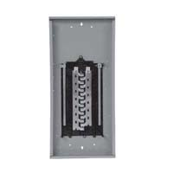](https://www.jhlarson.com/index.jsp?ID=/Distribution-Equipment-Accessories/Load-Centers/dept-4ZE&path=to&ds=dept)

[**Load Centers (+)**](https://www.jhlarson.com/index.jsp?ID=/Distribution-Equipment-Accessories/Load-Centers/dept-4ZE&path=to&ds=dept)

* + [**Generator Ready Load Centers**](https://www.jhlarson.com/index.jsp?ID=/Distribution-Equipment-Accessories/Load-Centers/Generator-Ready-Load-Centers/dept-4ZF&path=find&ds=dept&a=1)

* + [**Panel-Breaker Packages**](https://www.jhlarson.com/index.jsp?ID=/Distribution-Equipment-Accessories/Load-Centers/Panel-Breaker-Packages/dept-4ZG&path=find&ds=dept&a=1)

* + [**Single Phase Convertible Load Centers**](https://www.jhlarson.com/index.jsp?ID=/Distribution-Equipment-Accessories/Load-Centers/Single-Phase-Convertible-Load-Centers/dept-4ZH&path=find&ds=dept&a=1)

* + [**Single Phase Main Breaker Load Centers**](https://www.jhlarson.com/index.jsp?ID=/Distribution-Equipment-Accessories/Load-Centers/Single-Phase-Main-Breaker-Load-Centers/dept-4ZI&path=find&ds=dept&a=1)

* + [**Single Phase Main Lug Load Centers**](https://www.jhlarson.com/index.jsp?ID=/Distribution-Equipment-Accessories/Load-Centers/Single-Phase-Main-Lug-Load-Centers/dept-4ZJ&path=find&ds=dept&a=1)

* + [**Three Phase Main Breaker Load Centers**](https://www.jhlarson.com/index.jsp?ID=/Distribution-Equipment-Accessories/Load-Centers/Three-Phase-Main-Breaker-Load-Centers/dept-4ZM&path=find&ds=dept&a=1)

* + [**Three Phase Main Lug Load Centers**](https://www.jhlarson.com/index.jsp?ID=/Distribution-Equipment-Accessories/Load-Centers/Three-Phase-Main-Lug-Load-Centers/dept-4ZN&path=find&ds=dept&a=1)

* [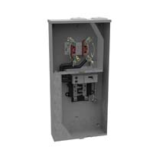](https://www.jhlarson.com/index.jsp?ID=/Distribution-Equipment-Accessories/Metering-Equipment/dept-4ZO&path=to&ds=dept)

[**Metering Equipment (+)**](https://www.jhlarson.com/index.jsp?ID=/Distribution-Equipment-Accessories/Metering-Equipment/dept-4ZO&path=to&ds=dept)

* + [**Meter Mains**](https://www.jhlarson.com/index.jsp?ID=/Distribution-Equipment-Accessories/Metering-Equipment/Meter-Mains/dept-4ZP&path=find&ds=dept&a=1)

* + [**Meter Packs**](https://www.jhlarson.com/index.jsp?ID=/Distribution-Equipment-Accessories/Metering-Equipment/Meter-Packs/dept-4ZQ&path=find&ds=dept&a=1)

* + [**Meter Pedestals**](https://www.jhlarson.com/index.jsp?ID=/Distribution-Equipment-Accessories/Metering-Equipment/Meter-Pedestals/dept-4ZR&path=find&ds=dept&a=1)

* + [**Meter Socket Circuit Breaker Combination**](https://www.jhlarson.com/index.jsp?ID=/Distribution-Equipment-Accessories/Metering-Equipment/Meter-Socket-Circuit-Breaker-Combination/dept-4ZS&path=find&ds=dept&a=1)

* + [**Meter Socket Loadcenter Combinations**](https://www.jhlarson.com/index.jsp?ID=/Distribution-Equipment-Accessories/Metering-Equipment/Meter-Socket-Loadcenter-Combinations/dept-4ZT&path=find&ds=dept&a=1)

* + [**Meter Socket Meter Main Combinations**](https://www.jhlarson.com/index.jsp?ID=/Distribution-Equipment-Accessories/Metering-Equipment/Meter-Socket-Meter-Main-Combinations/dept-89M&path=find&ds=dept&a=1)

* + [**Meter Sockets - Multi Position**](https://www.jhlarson.com/index.jsp?ID=/Distribution-Equipment-Accessories/Metering-Equipment/Meter-Sockets-Multi-Position/dept-4ZU&path=find&ds=dept&a=1)

* + [**Meter Sockets - Single Position**](https://www.jhlarson.com/index.jsp?ID=/Distribution-Equipment-Accessories/Metering-Equipment/Meter-Sockets-Single-Position/dept-4ZV&path=find&ds=dept&a=1)

* + [**Meter Sockets - Transformer Rated**](https://www.jhlarson.com/index.jsp?ID=/Distribution-Equipment-Accessories/Metering-Equipment/Meter-Sockets-Transformer-Rated/dept-89O&path=find&ds=dept&a=1)

* + [**Meter Stacks**](https://www.jhlarson.com/index.jsp?ID=/Distribution-Equipment-Accessories/Metering-Equipment/Meter-Stacks/dept-4ZW&path=find&ds=dept&a=1)

* + [**Post Stabilizer Bases**](https://www.jhlarson.com/index.jsp?ID=/Distribution-Equipment-Accessories/Metering-Equipment/Post-Stabilizer-Bases/dept-4ZX&path=find&ds=dept&a=1)

* + [**Safety Socket Bypass Meter Sockets**](https://www.jhlarson.com/index.jsp?ID=/Distribution-Equipment-Accessories/Metering-Equipment/Safety-Socket-Bypass-Meter-Sockets/dept-4ZY&path=find&ds=dept&a=1)

* [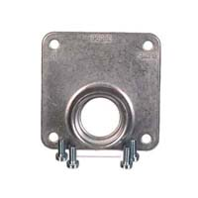](https://www.jhlarson.com/index.jsp?ID=/Distribution-Equipment-Accessories/Metering-Equipment-Accessories/dept-4ZZ&path=to&ds=dept)

[**Metering Equipment Accessories (+)**](https://www.jhlarson.com/index.jsp?ID=/Distribution-Equipment-Accessories/Metering-Equipment-Accessories/dept-4ZZ&path=to&ds=dept)

* + [**Meter Bussed Spacers**](https://www.jhlarson.com/index.jsp?ID=/Distribution-Equipment-Accessories/Metering-Equipment-Accessories/Meter-Bussed-Spacers/dept-89F&path=find&ds=dept&a=1)

* + [**Meter Bypass Kits**](https://www.jhlarson.com/index.jsp?ID=/Distribution-Equipment-Accessories/Metering-Equipment-Accessories/Meter-Bypass-Kits/dept-500&path=find&ds=dept&a=1)

* + [**Meter Hub Adapter Plates**](https://www.jhlarson.com/index.jsp?ID=/Distribution-Equipment-Accessories/Metering-Equipment-Accessories/Meter-Hub-Adapter-Plates/dept-501&path=find&ds=dept&a=1)

* + [**Meter Hub Closure Plates**](https://www.jhlarson.com/index.jsp?ID=/Distribution-Equipment-Accessories/Metering-Equipment-Accessories/Meter-Hub-Closure-Plates/dept-502&path=find&ds=dept&a=1)

* + [**Meter Hubs**](https://www.jhlarson.com/index.jsp?ID=/Distribution-Equipment-Accessories/Metering-Equipment-Accessories/Meter-Hubs/dept-503&path=find&ds=dept&a=1)

* + [**Meter Mounts**](https://www.jhlarson.com/index.jsp?ID=/Distribution-Equipment-Accessories/Metering-Equipment-Accessories/Meter-Mounts/dept-504&path=find&ds=dept&a=1)

* + [**Meter Rings**](https://www.jhlarson.com/index.jsp?ID=/Distribution-Equipment-Accessories/Metering-Equipment-Accessories/Meter-Rings/dept-89K&path=find&ds=dept&a=1)

* + [**Meter Socket Covers**](https://www.jhlarson.com/index.jsp?ID=/Distribution-Equipment-Accessories/Metering-Equipment-Accessories/Meter-Socket-Covers/dept-505&path=find&ds=dept&a=1)

* + [**Meter Sub-Feed Lug Blocks**](https://www.jhlarson.com/index.jsp?ID=/Distribution-Equipment-Accessories/Metering-Equipment-Accessories/Meter-Sub-Feed-Lug-Blocks/dept-89P&path=find&ds=dept&a=1)

* + [**Meter Terminals**](https://www.jhlarson.com/index.jsp?ID=/Distribution-Equipment-Accessories/Metering-Equipment-Accessories/Meter-Terminals/dept-506&path=find&ds=dept&a=1)

* + [**Meter Test Switches**](https://www.jhlarson.com/index.jsp?ID=/Distribution-Equipment-Accessories/Metering-Equipment-Accessories/Meter-Test-Switches/dept-507&path=find&ds=dept&a=1)

* + [**Metering Miscellaneous Accessories**](https://www.jhlarson.com/index.jsp?ID=/Distribution-Equipment-Accessories/Metering-Equipment-Accessories/Metering-Miscellaneous-Accessories/dept-508&path=find&ds=dept&a=1)

* [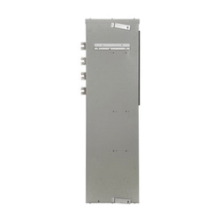](https://www.jhlarson.com/index.jsp?ID=/Distribution-Equipment-Accessories/Modular-Grouping-Metering/dept-509&path=to&ds=dept)

[**Modular & Grouping Metering (+)**](https://www.jhlarson.com/index.jsp?ID=/Distribution-Equipment-Accessories/Modular-Grouping-Metering/dept-509&path=to&ds=dept)

* + [**Main Circuit Breaker Modules**](https://www.jhlarson.com/index.jsp?ID=/Distribution-Equipment-Accessories/Modular-Grouping-Metering/Main-Circuit-Breaker-Modules/dept-50A&path=find&ds=dept&a=1)

* + [**Main Fusible Switch Modules**](https://www.jhlarson.com/index.jsp?ID=/Distribution-Equipment-Accessories/Modular-Grouping-Metering/Main-Fusible-Switch-Modules/dept-50B&path=find&ds=dept&a=1)

* + [**Main Lug Terminal Box Modules**](https://www.jhlarson.com/index.jsp?ID=/Distribution-Equipment-Accessories/Modular-Grouping-Metering/Main-Lug-Terminal-Box-Modules/dept-50C&path=find&ds=dept&a=1)

* + [**Main Pull Box Modules**](https://www.jhlarson.com/index.jsp?ID=/Distribution-Equipment-Accessories/Modular-Grouping-Metering/Main-Pull-Box-Modules/dept-89E&path=find&ds=dept&a=1)

* + [**Meter Stack Modules**](https://www.jhlarson.com/index.jsp?ID=/Distribution-Equipment-Accessories/Modular-Grouping-Metering/Meter-Stack-Modules/dept-50D&path=find&ds=dept&a=1)

* [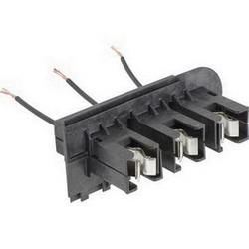](https://www.jhlarson.com/index.jsp?ID=/Distribution-Equipment-Accessories/Motor-Control-Centers-Accessories/dept-50E&path=to&ds=dept)

[**Motor Control Centers & Accessories (+)**](https://www.jhlarson.com/index.jsp?ID=/Distribution-Equipment-Accessories/Motor-Control-Centers-Accessories/dept-50E&path=to&ds=dept)

* + [**Circuit Breaker Branch Feeder Units**](https://www.jhlarson.com/index.jsp?ID=/Distribution-Equipment-Accessories/Motor-Control-Centers-Accessories/Circuit-Breaker-Branch-Feeder-Units/dept-88N&path=find&ds=dept&a=1)

* + [**Motor Control Center Accessories**](https://www.jhlarson.com/index.jsp?ID=/Distribution-Equipment-Accessories/Motor-Control-Centers-Accessories/Motor-Control-Center-Accessories/dept-50F&path=find&ds=dept&a=1)

* [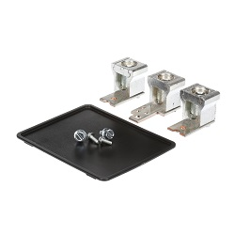](https://www.jhlarson.com/index.jsp?ID=/Distribution-Equipment-Accessories/Panelboards-Accessories/dept-50G&path=to&ds=dept)

[**Panelboards & Accessories (+)**](https://www.jhlarson.com/index.jsp?ID=/Distribution-Equipment-Accessories/Panelboards-Accessories/dept-50G&path=to&ds=dept)

* + [**Lighting Panelboards**](https://www.jhlarson.com/index.jsp?ID=/Distribution-Equipment-Accessories/Panelboards-Accessories/Lighting-Panelboards/dept-50H&path=find&ds=dept&a=1)

* + [**Panelboard Boxes**](https://www.jhlarson.com/index.jsp?ID=/Distribution-Equipment-Accessories/Panelboards-Accessories/Panelboard-Boxes/dept-50I&path=find&ds=dept&a=1)

* + [**Panelboard Breakers**](https://www.jhlarson.com/index.jsp?ID=/Distribution-Equipment-Accessories/Panelboards-Accessories/Panelboard-Breakers/dept-50J&path=find&ds=dept&a=1)

* + [**Panelboard Connection Kits**](https://www.jhlarson.com/index.jsp?ID=/Distribution-Equipment-Accessories/Panelboards-Accessories/Panelboard-Connection-Kits/dept-50K&path=find&ds=dept&a=1)

* + [**Panelboard Door Locks & Latches**](https://www.jhlarson.com/index.jsp?ID=/Distribution-Equipment-Accessories/Panelboards-Accessories/Panelboard-Door-Locks-Latches/dept-50L&path=find&ds=dept&a=1)

* + [**Panelboard Enclosures**](https://www.jhlarson.com/index.jsp?ID=/Distribution-Equipment-Accessories/Panelboards-Accessories/Panelboard-Enclosures/dept-50M&path=find&ds=dept&a=1)

* + [**Panelboard Filler Plates**](https://www.jhlarson.com/index.jsp?ID=/Distribution-Equipment-Accessories/Panelboards-Accessories/Panelboard-Filler-Plates/dept-50N&path=find&ds=dept&a=1)

* + [**Panelboard Fronts & Trims**](https://www.jhlarson.com/index.jsp?ID=/Distribution-Equipment-Accessories/Panelboards-Accessories/Panelboard-Fronts-Trims/dept-50O&path=find&ds=dept&a=1)

* + [**Panelboard Ground & Neutral Components**](https://www.jhlarson.com/index.jsp?ID=/Distribution-Equipment-Accessories/Panelboards-Accessories/Panelboard-Ground-Neutral-Components/dept-50P&path=find&ds=dept&a=1)

* + [**Panelboard Interiors**](https://www.jhlarson.com/index.jsp?ID=/Distribution-Equipment-Accessories/Panelboards-Accessories/Panelboard-Interiors/dept-50Q&path=find&ds=dept&a=1)

* + [**Panelboard Lugs**](https://www.jhlarson.com/index.jsp?ID=/Distribution-Equipment-Accessories/Panelboards-Accessories/Panelboard-Lugs/dept-50R&path=find&ds=dept&a=1)

* + [**Panelboard Miscellaneous Accessories**](https://www.jhlarson.com/index.jsp?ID=/Distribution-Equipment-Accessories/Panelboards-Accessories/Panelboard-Miscellaneous-Accessories/dept-50S&path=find&ds=dept&a=1)

* + [**Panelboard Mounting Accessories**](https://www.jhlarson.com/index.jsp?ID=/Distribution-Equipment-Accessories/Panelboards-Accessories/Panelboard-Mounting-Accessories/dept-50T&path=find&ds=dept&a=1)

* + [**Panelboard Service Entrance Kits**](https://www.jhlarson.com/index.jsp?ID=/Distribution-Equipment-Accessories/Panelboards-Accessories/Panelboard-Service-Entrance-Kits/dept-50U&path=find&ds=dept&a=1)

* [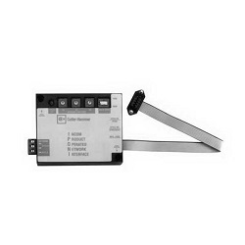](https://www.jhlarson.com/index.jsp?ID=/Distribution-Equipment-Accessories/Power-Energy-Monitoring-Systems/dept-50V&path=to&ds=dept)

[**Power & Energy Monitoring Systems (+)**](https://www.jhlarson.com/index.jsp?ID=/Distribution-Equipment-Accessories/Power-Energy-Monitoring-Systems/dept-50V&path=to&ds=dept)

* + [**Monitoring Meter Display**](https://www.jhlarson.com/index.jsp?ID=/Distribution-Equipment-Accessories/Power-Energy-Monitoring-Systems/Monitoring-Meter-Display/dept-89Y&path=find&ds=dept&a=1)

* [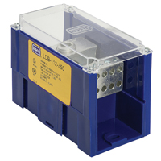](https://www.jhlarson.com/index.jsp?ID=/Distribution-Equipment-Accessories/Power-Distribution-Blocks/dept-50X&path=to&ds=dept)

[**Power Distribution Blocks (+)**](https://www.jhlarson.com/index.jsp?ID=/Distribution-Equipment-Accessories/Power-Distribution-Blocks/dept-50X&path=to&ds=dept)

* + [**Distribution Block Covers**](https://www.jhlarson.com/index.jsp?ID=/Distribution-Equipment-Accessories/Power-Distribution-Blocks/Distribution-Block-Covers/dept-50Y&path=find&ds=dept&a=1)

* + [**Multi Pole Distribution Blocks**](https://www.jhlarson.com/index.jsp?ID=/Distribution-Equipment-Accessories/Power-Distribution-Blocks/Multi-Pole-Distribution-Blocks/dept-50Z&path=find&ds=dept&a=1)

* + [**Single Pole Distribution Blocks**](https://www.jhlarson.com/index.jsp?ID=/Distribution-Equipment-Accessories/Power-Distribution-Blocks/Single-Pole-Distribution-Blocks/dept-510&path=find&ds=dept&a=1)

* [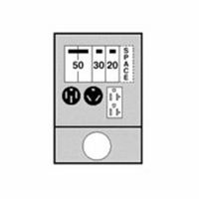](https://www.jhlarson.com/index.jsp?ID=/Distribution-Equipment-Accessories/Power-Outlet-Panels/dept-511&path=to&ds=dept)

[**Power Outlet Panels (+)**](https://www.jhlarson.com/index.jsp?ID=/Distribution-Equipment-Accessories/Power-Outlet-Panels/dept-511&path=to&ds=dept)

* + [**Electric Vehicle Charging Stations**](https://www.jhlarson.com/index.jsp?ID=/Distribution-Equipment-Accessories/Power-Outlet-Panels/Electric-Vehicle-Charging-Stations/dept-892&path=find&ds=dept&a=1)

* + [**Electric Vehicle Charging Station Accessories**](https://www.jhlarson.com/index.jsp?ID=/Distribution-Equipment-Accessories/Power-Outlet-Panels/Electric-Vehicle-Charging-Station-Accessories/dept-891&path=find&ds=dept&a=1)

* + [**Metered Power Outlet Panels**](https://www.jhlarson.com/index.jsp?ID=/Distribution-Equipment-Accessories/Power-Outlet-Panels/Metered-Power-Outlet-Panels/dept-512&path=find&ds=dept&a=1)

* + [**Metered Power Outlet Pedestals**](https://www.jhlarson.com/index.jsp?ID=/Distribution-Equipment-Accessories/Power-Outlet-Panels/Metered-Power-Outlet-Pedestals/dept-513&path=find&ds=dept&a=1)

* + [**Power Outlet Panel & Pedestal Access.**](https://www.jhlarson.com/index.jsp?ID=/Distribution-Equipment-Accessories/Power-Outlet-Panels/Power-Outlet-Panel-Pedestal-Access/dept-514&path=find&ds=dept&a=1)

* + [**Unmetered Power Outlet Panels**](https://www.jhlarson.com/index.jsp?ID=/Distribution-Equipment-Accessories/Power-Outlet-Panels/Unmetered-Power-Outlet-Panels/dept-515&path=find&ds=dept&a=1)

* + [**Unmetered Power Outlet Pedestals**](https://www.jhlarson.com/index.jsp?ID=/Distribution-Equipment-Accessories/Power-Outlet-Panels/Unmetered-Power-Outlet-Pedestals/dept-516&path=find&ds=dept&a=1)

* [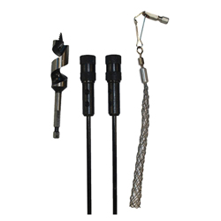](https://www.jhlarson.com/index.jsp?ID=/Distribution-Equipment-Accessories/Safety-Disconnect-Switch-Accessories/dept-517&path=to&ds=dept)

[**Safety & Disconnect Switch Accessories (+)**](https://www.jhlarson.com/index.jsp?ID=/Distribution-Equipment-Accessories/Safety-Disconnect-Switch-Accessories/dept-517&path=to&ds=dept)

* + [**Disconnect Switch Handle Shafts**](https://www.jhlarson.com/index.jsp?ID=/Distribution-Equipment-Accessories/Safety-Disconnect-Switch-Accessories/Disconnect-Switch-Handle-Shafts/dept-518&path=find&ds=dept&a=1)

* + [**Disconnect Switch Operating Handles**](https://www.jhlarson.com/index.jsp?ID=/Distribution-Equipment-Accessories/Safety-Disconnect-Switch-Accessories/Disconnect-Switch-Operating-Handles/dept-88W&path=find&ds=dept&a=1)

* + [**Safety/Disconnect Auxiliary Contacts**](https://www.jhlarson.com/index.jsp?ID=/Distribution-Equipment-Accessories/Safety-Disconnect-Switch-Accessories/Safety-Disconnect-Auxiliary-Contacts/dept-519&path=find&ds=dept&a=1)

* + [**Safety/Disconnect Auxiliary Switches**](https://www.jhlarson.com/index.jsp?ID=/Distribution-Equipment-Accessories/Safety-Disconnect-Switch-Accessories/Safety-Disconnect-Auxiliary-Switches/dept-8A4&path=find&ds=dept&a=1)

* + [**Safety/Disconnect Fuse Clip Kits**](https://www.jhlarson.com/index.jsp?ID=/Distribution-Equipment-Accessories/Safety-Disconnect-Switch-Accessories/Safety-Disconnect-Fuse-Clip-Kits/dept-51A&path=find&ds=dept&a=1)

* + [**Safety/Disconnect Miscellaneous Accessories**](https://www.jhlarson.com/index.jsp?ID=/Distribution-Equipment-Accessories/Safety-Disconnect-Switch-Accessories/Safety-Disconnect-Miscellaneous-Accessories/dept-51C&path=find&ds=dept&a=1)

* + [**Safety/Disconnect Switch Bases**](https://www.jhlarson.com/index.jsp?ID=/Distribution-Equipment-Accessories/Safety-Disconnect-Switch-Accessories/Safety-Disconnect-Switch-Bases/dept-51D&path=find&ds=dept&a=1)

* + [**Safety/Disconnect Switch Fuse Covers**](https://www.jhlarson.com/index.jsp?ID=/Distribution-Equipment-Accessories/Safety-Disconnect-Switch-Accessories/Safety-Disconnect-Switch-Fuse-Covers/dept-51E&path=find&ds=dept&a=1)

* + [**Safety/Disconnect Switch Fuse Kits**](https://www.jhlarson.com/index.jsp?ID=/Distribution-Equipment-Accessories/Safety-Disconnect-Switch-Accessories/Safety-Disconnect-Switch-Fuse-Kits/dept-51F&path=find&ds=dept&a=1)

* + [**Safety/Disconnect Switch Hubs**](https://www.jhlarson.com/index.jsp?ID=/Distribution-Equipment-Accessories/Safety-Disconnect-Switch-Accessories/Safety-Disconnect-Switch-Hubs/dept-51G&path=find&ds=dept&a=1)

* + [**Safety/Disconnect Terminal Lugs**](https://www.jhlarson.com/index.jsp?ID=/Distribution-Equipment-Accessories/Safety-Disconnect-Switch-Accessories/Safety-Disconnect-Terminal-Lugs/dept-51H&path=find&ds=dept&a=1)

* + [**Switch Ground & Neutral Components**](https://www.jhlarson.com/index.jsp?ID=/Distribution-Equipment-Accessories/Safety-Disconnect-Switch-Accessories/Switch-Ground-Neutral-Components/dept-51I&path=find&ds=dept&a=1)

* [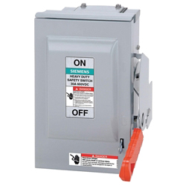](https://www.jhlarson.com/index.jsp?ID=/Distribution-Equipment-Accessories/Safety-Disconnect-Switches/dept-51J&path=to&ds=dept)

[**Safety & Disconnect Switches (+)**](https://www.jhlarson.com/index.jsp?ID=/Distribution-Equipment-Accessories/Safety-Disconnect-Switches/dept-51J&path=to&ds=dept)

* + [**Air-Conditioner Disconnects**](https://www.jhlarson.com/index.jsp?ID=/Distribution-Equipment-Accessories/Safety-Disconnect-Switches/Air-Conditioner-Disconnects/dept-51K&path=find&ds=dept&a=1)

* + [**Double Throw Safety Switches**](https://www.jhlarson.com/index.jsp?ID=/Distribution-Equipment-Accessories/Safety-Disconnect-Switches/Double-Throw-Safety-Switches/dept-51L&path=find&ds=dept&a=1)

* + [**Double Throw Disconnects**](https://www.jhlarson.com/index.jsp?ID=/Distribution-Equipment-Accessories/Safety-Disconnect-Switches/Double-Throw-Disconnects/dept-51M&path=find&ds=dept&a=1)

* + [**Enclosed Rotary Disconnects**](https://www.jhlarson.com/index.jsp?ID=/Distribution-Equipment-Accessories/Safety-Disconnect-Switches/Enclosed-Rotary-Disconnects/dept-51N&path=find&ds=dept&a=1)

* + [**Flange Mount Disconnects**](https://www.jhlarson.com/index.jsp?ID=/Distribution-Equipment-Accessories/Safety-Disconnect-Switches/Flange-Mount-Disconnects/dept-51O&path=find&ds=dept&a=1)

* + [**General Duty Safety Switches**](https://www.jhlarson.com/index.jsp?ID=/Distribution-Equipment-Accessories/Safety-Disconnect-Switches/General-Duty-Safety-Switches/dept-51P&path=find&ds=dept&a=1)

* + [**Hazardous Location Disconnect Switches**](https://www.jhlarson.com/index.jsp?ID=/Distribution-Equipment-Accessories/Safety-Disconnect-Switches/Hazardous-Location-Disconnect-Switches/dept-897&path=find&ds=dept&a=1)

* + [**Hazardous Location Safety Switches**](https://www.jhlarson.com/index.jsp?ID=/Distribution-Equipment-Accessories/Safety-Disconnect-Switches/Hazardous-Location-Safety-Switches/dept-51Q&path=find&ds=dept&a=1)

* + [**Heavy Duty Safety Switches**](https://www.jhlarson.com/index.jsp?ID=/Distribution-Equipment-Accessories/Safety-Disconnect-Switches/Heavy-Duty-Safety-Switches/dept-51R&path=find&ds=dept&a=1)

* + [**Light Duty Safety Switches**](https://www.jhlarson.com/index.jsp?ID=/Distribution-Equipment-Accessories/Safety-Disconnect-Switches/Light-Duty-Safety-Switches/dept-899&path=find&ds=dept&a=1)

* + [**Open Rotary Control Disconnects**](https://www.jhlarson.com/index.jsp?ID=/Distribution-Equipment-Accessories/Safety-Disconnect-Switches/Open-Rotary-Control-Disconnects/dept-51S&path=find&ds=dept&a=1)

* + [**Panel Board Disconnects**](https://www.jhlarson.com/index.jsp?ID=/Distribution-Equipment-Accessories/Safety-Disconnect-Switches/Panel-Board-Disconnects/dept-51T&path=find&ds=dept&a=1)

* + [**Single-Throw Disconnects**](https://www.jhlarson.com/index.jsp?ID=/Distribution-Equipment-Accessories/Safety-Disconnect-Switches/Single-Throw-Disconnects/dept-51U&path=find&ds=dept&a=1)

* + [**Special Application Safety Switches**](https://www.jhlarson.com/index.jsp?ID=/Distribution-Equipment-Accessories/Safety-Disconnect-Switches/Special-Application-Safety-Switches/dept-51V&path=find&ds=dept&a=1)

* + [**Toggle Disconnects**](https://www.jhlarson.com/index.jsp?ID=/Distribution-Equipment-Accessories/Safety-Disconnect-Switches/Toggle-Disconnects/dept-51W&path=find&ds=dept&a=1)

* [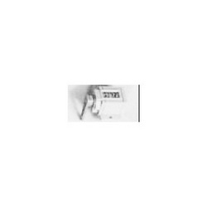](https://www.jhlarson.com/index.jsp?ID=/Distribution-Equipment-Accessories/Switchgears-Accessories/dept-8AB&path=to&ds=dept)

[**Switchgears & Accessories (+)**](https://www.jhlarson.com/index.jsp?ID=/Distribution-Equipment-Accessories/Switchgears-Accessories/dept-8AB&path=to&ds=dept)

* [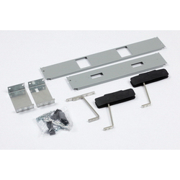](https://www.jhlarson.com/index.jsp?ID=/Distribution-Equipment-Accessories/Switch-Boards-Accessories/dept-89B&path=to&ds=dept)

[**Switch Boards & Accessories (+)**](https://www.jhlarson.com/index.jsp?ID=/Distribution-Equipment-Accessories/Switch-Boards-Accessories/dept-89B&path=to&ds=dept)

* + [**Switchboard Components**](https://www.jhlarson.com/index.jsp?ID=/Distribution-Equipment-Accessories/Switch-Boards-Accessories/Switchboard-Components/dept-8AA&path=find&ds=dept&a=1)

**HVAC Equipment**

* [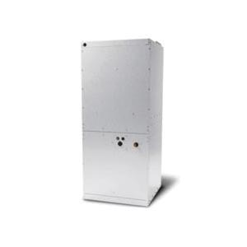](https://www.jhlarson.com/index.jsp?ID=/HVAC-Equipment/Air-Handling-Units/dept-5IM&path=to&ds=dept)

[**Air Handling Units (+)**](https://www.jhlarson.com/index.jsp?ID=/HVAC-Equipment/Air-Handling-Units/dept-5IM&path=to&ds=dept)

* + [**Residential Wall Mount Air Handlers**](https://www.jhlarson.com/index.jsp?ID=/HVAC-Equipment/Air-Handling-Units/Residential-Wall-Mount-Air-Handlers/dept-5IN&path=find&ds=dept&a=1)

* [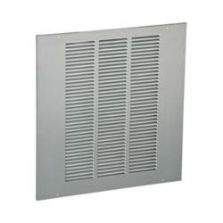](https://www.jhlarson.com/index.jsp?ID=/HVAC-Equipment/Chiller-Units/dept-7JB&path=to&ds=dept)

[**Chiller Units (+)**](https://www.jhlarson.com/index.jsp?ID=/HVAC-Equipment/Chiller-Units/dept-7JB&path=to&ds=dept)

* [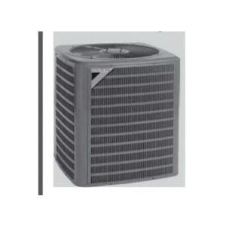](https://www.jhlarson.com/index.jsp?ID=/HVAC-Equipment/Condensers-Air-Conditioners/dept-88F&path=find&ds=dept&a=1)

[**Condensers & Air Conditioners (6)**](https://www.jhlarson.com/index.jsp?ID=/HVAC-Equipment/Condensers-Air-Conditioners/dept-88F&path=find&ds=dept&a=1)

* [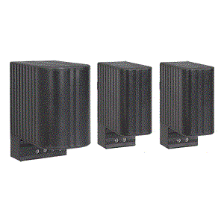](https://www.jhlarson.com/index.jsp?ID=/HVAC-Equipment/Electric-Process-Heaters/dept-5IO&path=to&ds=dept)

[**Electric Process Heaters (+)**](https://www.jhlarson.com/index.jsp?ID=/HVAC-Equipment/Electric-Process-Heaters/dept-5IO&path=to&ds=dept)

* + [**Strip Heaters**](https://www.jhlarson.com/index.jsp?ID=/HVAC-Equipment/Electric-Process-Heaters/Strip-Heaters/dept-5IR&path=find&ds=dept&a=1)

* [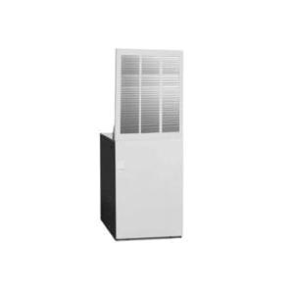](https://www.jhlarson.com/index.jsp?ID=/HVAC-Equipment/Furnaces/dept-5IS&path=to&ds=dept)

[**Furnaces (+)**](https://www.jhlarson.com/index.jsp?ID=/HVAC-Equipment/Furnaces/dept-5IS&path=to&ds=dept)

* + [**Gas Furnaces**](https://www.jhlarson.com/index.jsp?ID=/HVAC-Equipment/Furnaces/Gas-Furnaces/dept-5IT&path=find&ds=dept&a=1)

* [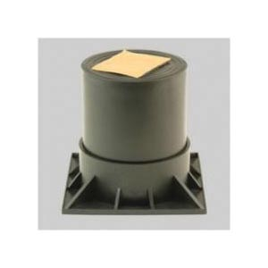](https://www.jhlarson.com/index.jsp?ID=/HVAC-Equipment/Heat-Pumps/dept-5IU&path=to&ds=dept)

[**Heat Pumps (+)**](https://www.jhlarson.com/index.jsp?ID=/HVAC-Equipment/Heat-Pumps/dept-5IU&path=to&ds=dept)

* + [**Heat Pump Accessories**](https://www.jhlarson.com/index.jsp?ID=/HVAC-Equipment/Heat-Pumps/Heat-Pump-Accessories/dept-7JF&path=find&ds=dept&a=1)

* + [**Heat Pump Risers**](https://www.jhlarson.com/index.jsp?ID=/HVAC-Equipment/Heat-Pumps/Heat-Pump-Risers/dept-5IV&path=find&ds=dept&a=1)

* [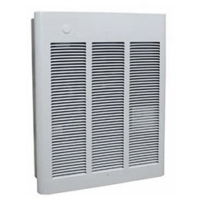](https://www.jhlarson.com/index.jsp?ID=/HVAC-Equipment/Heaters/dept-5IW&path=to&ds=dept)

[**Heaters (+)**](https://www.jhlarson.com/index.jsp?ID=/HVAC-Equipment/Heaters/dept-5IW&path=to&ds=dept)

* + [**Electric Baseboard Heaters**](https://www.jhlarson.com/index.jsp?ID=/HVAC-Equipment/Heaters/Electric-Baseboard-Heaters/dept-5IX&path=find&ds=dept&a=1)

* + [**Electric Fan Coil Heaters**](https://www.jhlarson.com/index.jsp?ID=/HVAC-Equipment/Heaters/Electric-Fan-Coil-Heaters/dept-7JH&path=find&ds=dept&a=1)

* + [**Electric Infrared Heaters**](https://www.jhlarson.com/index.jsp?ID=/HVAC-Equipment/Heaters/Electric-Infrared-Heaters/dept-5IY&path=find&ds=dept&a=1)

* + [**Electric Unit Heaters**](https://www.jhlarson.com/index.jsp?ID=/HVAC-Equipment/Heaters/Electric-Unit-Heaters/dept-5IZ&path=find&ds=dept&a=1)

* + [**Electric Utility Heaters**](https://www.jhlarson.com/index.jsp?ID=/HVAC-Equipment/Heaters/Electric-Utility-Heaters/dept-5J0&path=find&ds=dept&a=1)

* + [**Garage Heaters**](https://www.jhlarson.com/index.jsp?ID=/HVAC-Equipment/Heaters/Garage-Heaters/dept-7J1&path=find&ds=dept&a=1)

* + [**Gas Unit Heaters**](https://www.jhlarson.com/index.jsp?ID=/HVAC-Equipment/Heaters/Gas-Unit-Heaters/dept-7JI&path=find&ds=dept&a=1)

* + [**Kickspace Heaters**](https://www.jhlarson.com/index.jsp?ID=/HVAC-Equipment/Heaters/Kickspace-Heaters/dept-7JJ&path=find&ds=dept&a=1)

* + [**Portable Electric Heaters**](https://www.jhlarson.com/index.jsp?ID=/HVAC-Equipment/Heaters/Portable-Electric-Heaters/dept-5J1&path=find&ds=dept&a=1)

* + [**Radiant Cove Heaters**](https://www.jhlarson.com/index.jsp?ID=/HVAC-Equipment/Heaters/Radiant-Cove-Heaters/dept-5J2&path=find&ds=dept&a=1)

* [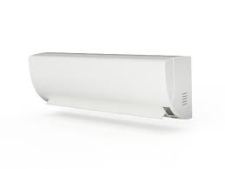](https://www.jhlarson.com/index.jsp?ID=/HVAC-Equipment/Mini-Split-Systems/dept-6RR&path=find&ds=dept&a=1)

[**Mini Split Systems (22)**](https://www.jhlarson.com/index.jsp?ID=/HVAC-Equipment/Mini-Split-Systems/dept-6RR&path=find&ds=dept&a=1)

* [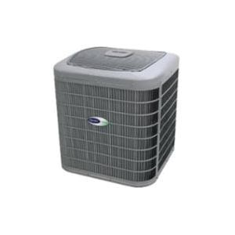](https://www.jhlarson.com/index.jsp?ID=/HVAC-Equipment/Packaged-Units/dept-5J3&path=to&ds=dept)

[**Packaged Units (+)**](https://www.jhlarson.com/index.jsp?ID=/HVAC-Equipment/Packaged-Units/dept-5J3&path=to&ds=dept)

* + [**Air Conditioner Packaged Units**](https://www.jhlarson.com/index.jsp?ID=/HVAC-Equipment/Packaged-Units/Air-Conditioner-Packaged-Units/dept-5J4&path=find&ds=dept&a=1)

**Heat Cables**

* [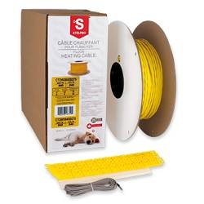](https://www.jhlarson.com/index.jsp?ID=/Heat-Cables/Floor-Warming/dept-5HG&path=to&ds=dept)

[**Floor Warming (+)**](https://www.jhlarson.com/index.jsp?ID=/Heat-Cables/Floor-Warming/dept-5HG&path=to&ds=dept)

* + [**Floor Heating Cables**](https://www.jhlarson.com/index.jsp?ID=/Heat-Cables/Floor-Warming/Floor-Heating-Cables/dept-7HP&path=find&ds=dept&a=1)

* + [**Floor Heating Mats**](https://www.jhlarson.com/index.jsp?ID=/Heat-Cables/Floor-Warming/Floor-Heating-Mats/dept-5HH&path=find&ds=dept&a=1)

* [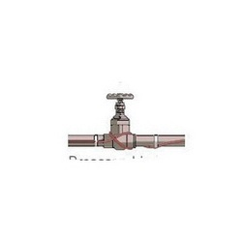](https://www.jhlarson.com/index.jsp?ID=/Heat-Cables/Hazardous-Area-Heat-Trace/dept-5HI&path=to&ds=dept)

[**Hazardous Area Heat Trace (+)**](https://www.jhlarson.com/index.jsp?ID=/Heat-Cables/Hazardous-Area-Heat-Trace/dept-5HI&path=to&ds=dept)

* + [**Self-regulating Heating Cables**](https://www.jhlarson.com/index.jsp?ID=/Heat-Cables/Hazardous-Area-Heat-Trace/Self-regulating-Heating-Cables/dept-5HJ&path=find&ds=dept&a=1)

* [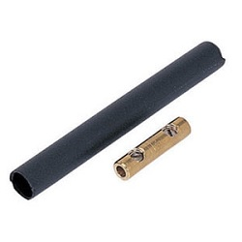](https://www.jhlarson.com/index.jsp?ID=/Heat-Cables/Heat-Cable-Accessories/dept-5HK&path=to&ds=dept)

[**Heat Cable Accessories (+)**](https://www.jhlarson.com/index.jsp?ID=/Heat-Cables/Heat-Cable-Accessories/dept-5HK&path=to&ds=dept)

* + [**Heat Cable Connection Accessories**](https://www.jhlarson.com/index.jsp?ID=/Heat-Cables/Heat-Cable-Accessories/Heat-Cable-Connection-Accessories/dept-5HL&path=find&ds=dept&a=1)

* + [**Heat Cable Installation Kits**](https://www.jhlarson.com/index.jsp?ID=/Heat-Cables/Heat-Cable-Accessories/Heat-Cable-Installation-Kits/dept-5HM&path=find&ds=dept&a=1)

* + [**Heat Cable Splice Kits**](https://www.jhlarson.com/index.jsp?ID=/Heat-Cables/Heat-Cable-Accessories/Heat-Cable-Splice-Kits/dept-5HN&path=find&ds=dept&a=1)

* + [**Heating Circuit Monitors**](https://www.jhlarson.com/index.jsp?ID=/Heat-Cables/Heat-Cable-Accessories/Heating-Circuit-Monitors/dept-7HS&path=find&ds=dept&a=1)

* + [**Heat Trace Brackets & Clips**](https://www.jhlarson.com/index.jsp?ID=/Heat-Cables/Heat-Cable-Accessories/Heat-Trace-Brackets-Clips/dept-5HO&path=find&ds=dept&a=1)

* + [**Heat Trace Connector Kits**](https://www.jhlarson.com/index.jsp?ID=/Heat-Cables/Heat-Cable-Accessories/Heat-Trace-Connector-Kits/dept-5HP&path=find&ds=dept&a=1)

* + [**Heat Trace Elec. Display & Control Units**](https://www.jhlarson.com/index.jsp?ID=/Heat-Cables/Heat-Cable-Accessories/Heat-Trace-Elec-Display-Control-Units/dept-5HQ&path=find&ds=dept&a=1)

* + [**Heat Trace Ice & Snow Detectors**](https://www.jhlarson.com/index.jsp?ID=/Heat-Cables/Heat-Cable-Accessories/Heat-Trace-Ice-Snow-Detectors/dept-5HR&path=find&ds=dept&a=1)

* + [**Heat Trace Junction Boxes**](https://www.jhlarson.com/index.jsp?ID=/Heat-Cables/Heat-Cable-Accessories/Heat-Trace-Junction-Boxes/dept-7HR&path=find&ds=dept&a=1)

* + [**Heat Trace Thermostats**](https://www.jhlarson.com/index.jsp?ID=/Heat-Cables/Heat-Cable-Accessories/Heat-Trace-Thermostats/dept-5HS&path=find&ds=dept&a=1)

* [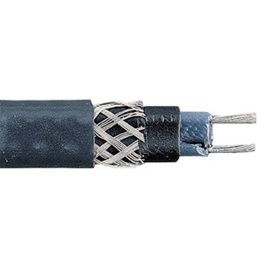](https://www.jhlarson.com/index.jsp?ID=/Heat-Cables/Pipe-Tracing/dept-5HT&path=to&ds=dept)

[**Pipe Tracing (+)**](https://www.jhlarson.com/index.jsp?ID=/Heat-Cables/Pipe-Tracing/dept-5HT&path=to&ds=dept)

* + [**Self-Regulating Pipe Cables**](https://www.jhlarson.com/index.jsp?ID=/Heat-Cables/Pipe-Tracing/Self-Regulating-Pipe-Cables/dept-5HU&path=find&ds=dept&a=1)

* [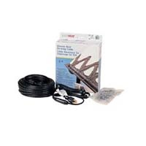](https://www.jhlarson.com/index.jsp?ID=/Heat-Cables/Roof-Gutter-De-icing/dept-5HV&path=to&ds=dept)

[**Roof & Gutter De-icing (+)**](https://www.jhlarson.com/index.jsp?ID=/Heat-Cables/Roof-Gutter-De-icing/dept-5HV&path=to&ds=dept)

* + [**Constant Wattage R&G De-Icing Cables**](https://www.jhlarson.com/index.jsp?ID=/Heat-Cables/Roof-Gutter-De-icing/Constant-Wattage-R-G-De-Icing-Cables/dept-5HW&path=find&ds=dept&a=1)

* + [**Self-Regulating R&G De-Icing Cables**](https://www.jhlarson.com/index.jsp?ID=/Heat-Cables/Roof-Gutter-De-icing/Self-Regulating-R-G-De-Icing-Cables/dept-8D9&path=find&ds=dept&a=1)

* [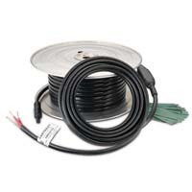](https://www.jhlarson.com/index.jsp?ID=/Heat-Cables/Snow-Melting/dept-5HX&path=to&ds=dept)

[**Snow Melting (+)**](https://www.jhlarson.com/index.jsp?ID=/Heat-Cables/Snow-Melting/dept-5HX&path=to&ds=dept)

* + [**Constant Wattage Snow Melt Cables**](https://www.jhlarson.com/index.jsp?ID=/Heat-Cables/Snow-Melting/Constant-Wattage-Snow-Melt-Cables/dept-5HY&path=find&ds=dept&a=1)

* [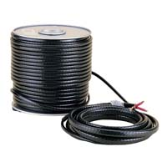](https://www.jhlarson.com/index.jsp?ID=/Heat-Cables/Specialty-Heating-Systems/dept-7HY&path=to&ds=dept)

[**Specialty Heating Systems (+)**](https://www.jhlarson.com/index.jsp?ID=/Heat-Cables/Specialty-Heating-Systems/dept-7HY&path=to&ds=dept)

* + [**Heating Cords & Tapes**](https://www.jhlarson.com/index.jsp?ID=/Heat-Cables/Specialty-Heating-Systems/Heating-Cords-Tapes/dept-7I1&path=find&ds=dept&a=1)