SPARCCOM TECNOLOGIES

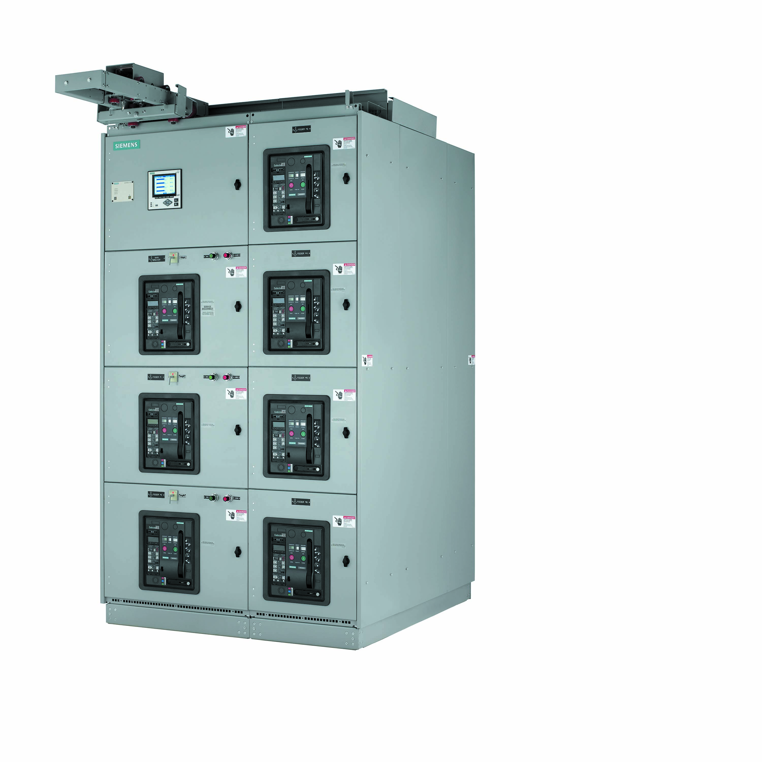

**Rear Connected Low Voltage Switchgear**

Reliable and safe solution for power distribution systems

Reliability and safety are the two most important criteria in the proper functioning of a power distribution system, but both can be compromised if an electrical fault occurs. By integrating the right low voltage switchgear, greater reliability and safer operation can be achieved in the power distribution system.Siemens Type WL low voltage metal-enclosed switchgear is designed, constructed and tested to provide superior power distribution, power monitoring and control. At the heart of the product is the World Class WL breaker. The WL breaker has a proven performance track record of proven technology and quality.

* **Products Detail**
* **Literature**
* **FAQs**

**Product Details**

Best-in-class pre-sales application and post-sales customer support

* Best-in-class arc flash mitigation solutions
* Modular design for maximum configuration flexibility
* Control and communication termination area located in front of equipment and segregated from power cable termination area that is located in rear of equipment
* Front accessible vertical and horizontal wiring channels
* No heat sinks on breaker or bus
* Three levels of horizontal bus through 5000 amps
* Breaker racking handle integral to the breaker
* All breaker settings and displays clearly visible with breaker door closed
* Field installable “drop in place” accessories and trip units
* Same accessories work for entire breaker line
* ModBus, ProfiBus and Ethernet communication
* Field installable ground fault protection and zone selective interlock
* Rogowski coil current sensors provide high metering accuracy and prevent saturation at high current levels

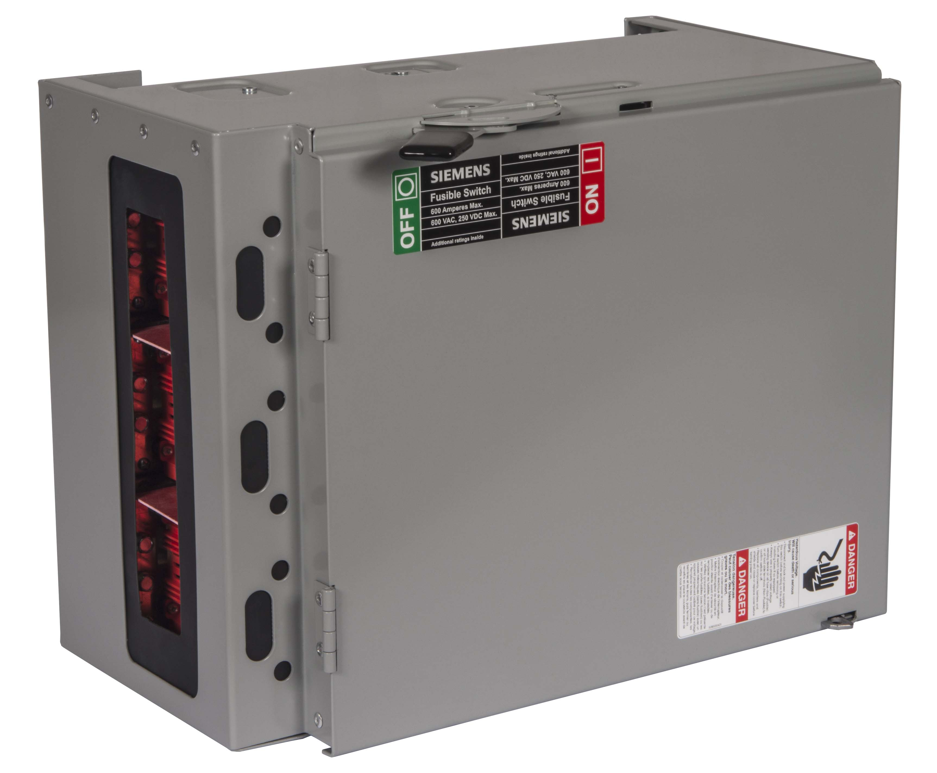

**Panel Switches**

The industry's most trusted safety switches

Siemens panelboard switches are available in a wide range of amerages with a variety of twin mounted versions for either group or individual mountings. Our panel switches offer the best in class safety with shunt trip options that can be used when ground fault protection is required. These switches are Siemens engineered with the signature Vacu-Break design that has a long track record of longevity and rugged durability.

* **Products Detail**
* **Literature**
* **FAQs**

**Product Details**

Amperage

-30-1200A

Voltage ratings

-240V-600V AC 250V DC

Number of Poles

-2-3

UL Listing

-UL98 listed in file #E6849

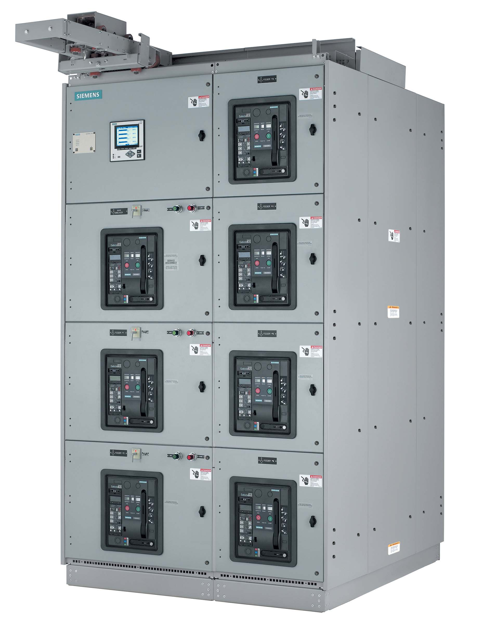

**Arc Resistant Low Voltage Switchgear**

Added degree of personnel protection with arc resistant low voltage

Siemens now offers arc resistant, metal-enclosed, low voltage switchgear solution designed to provide an additional degree of protection for personnel performing normal operating duties in proximity to the energized equipment. Such duties include opening or closing breakers, closed door breaker racking, reading instruments, or other activities that do not require cover removal or opening doors (other than auxiliary/instrument doors).

* **Products Detail**
* **Literature**
* **FAQs**

**Product Details**

* UL listed, performance tested and classified as arc resistant in accordance with ANSI/IEEE C37.20.7-2007
* ANSI/IEEE Type 2B accessibility rating to protect personnel at the front, back and sides of the equipment.
* Maximum internal arcing short-circuit current: 100kA @ 508V and 85 kA @ 635V
* Maximum arcing duration: 500 ms

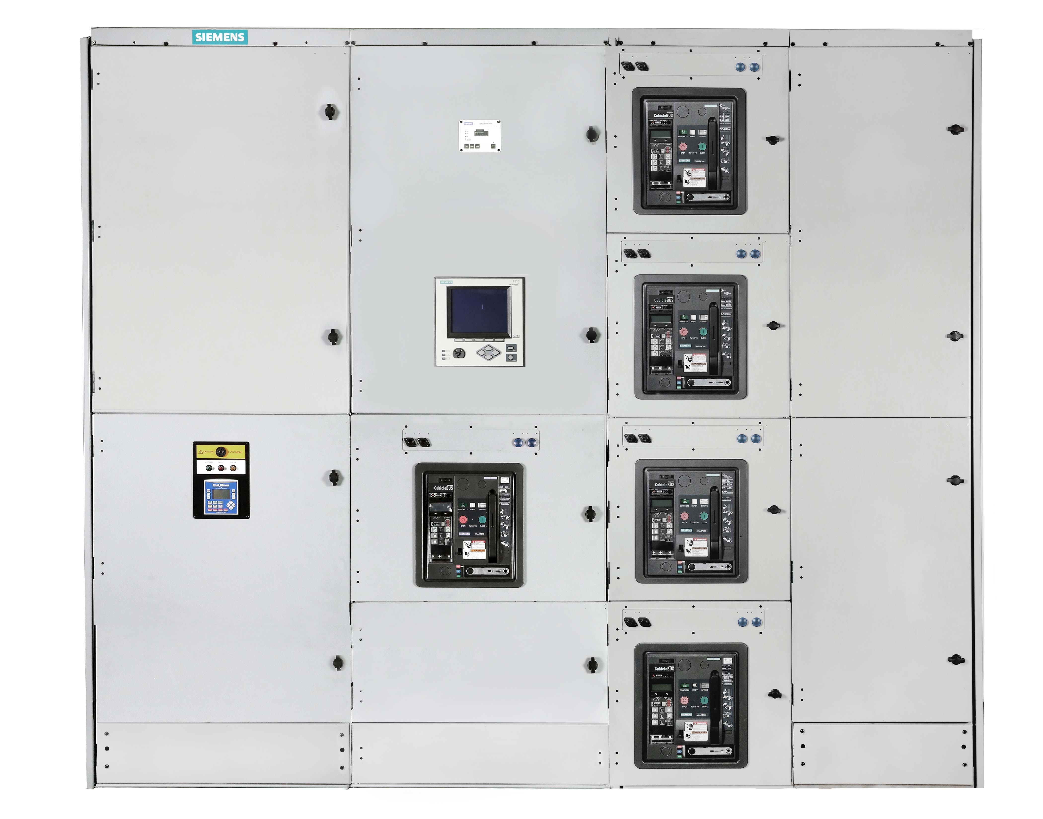

**Front Connected Low Voltage Switchgear**

Front connection accessibility

Front connected low voltage switchgear is designed to have all customer connections (incoming cable lugs, outgoing cable lugs, ground lugs, neutral disconnect, etc.) accessible from the front of the equipment. Additionally, front connected low voltage switchgear requires no rear access and can be mounted directly against a wall. With front connected low voltage switchgear, the rear breaker connection compartment is physically relocated to a separate vertical section beside the vertical section containing the breakers.

* **Products Detail**
* **Literature**
* **FAQs**

**Product Details**

* All customer connections are accessible from the front of the switchgear
* Breaker compartmentalization
* Industry leading footprint
* Front mounted common breaker plug-in accessories – easy to install
* Field upgradeable trip units
* Channel shaped vertical bus that provides superior thermal & short circuit withstand performance
* Modbus, Profibus, or Ethernet communication
* Supports energy management and power quality analysis through advanced breaker metering and relaying capability
* Dynamic Arc Flash Sentry (DAS) – dual breaker parameter setting capability
* Optional arc-resistant construction is available

**Equipment ratings**

Enclosure options

-NEMA 1 Indoor

Vertical section depth

-39.2"

Maximum system voltage

-635V AC

Maximum breaker amperage

-5000A

Maximum horizontal bus amperage

-5000A

Maximum vertical bus amperage

-5000A

Maximum short-circuit withstand rating (4 cycle)

-100kA

Maximum short-time withstand rating (60 cycle)

-100kA

Breaker construction

-3 pole drawout

Bus bar material

-silver plated copper

ANSI/IEEE

-C37.13, C37.16, C37.17, C37.20.1, C37.50, C37.51

UL

-1066, 1558

NEMA

-SG3, SG5

**Available options**

* Sm@rtGear
* Insulated/isolated bus
* Seismic certification – IBC, CBC, OSHPD
* CSA C22.2 No. 31 (cUL labeling)

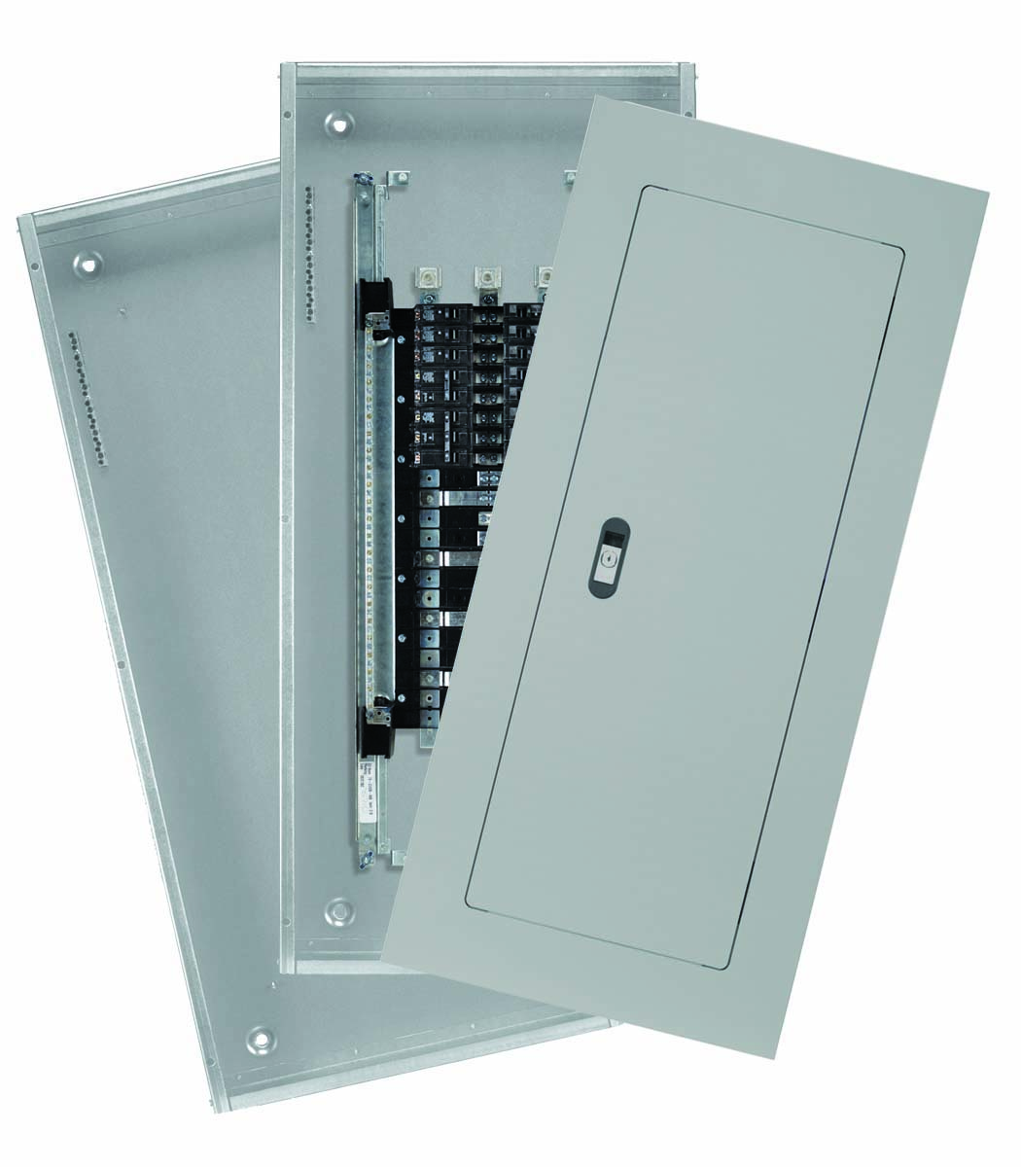

3D View

**Lighting Panels**

New generation of Lighting Panel products that represents the high level of engineering innovation

With flexibility and strength added to the existing rugged and durable panelboard family Siemens panelboards are extremely easy to install. These newer designs also simplify wiring and reduce material requirements saving additional installation time. Siemens also offers unassembled panelboards which are designed to meet shorter lead time requirements, provide product flexibility, and affordable pricing.

* **Products Detail**
* **P1 Accessories**
* **P2 Accessories**
* **P3 Accessories**
* **Literature**
* **Legacy Products**
* **FAQs**

**Product Details**

* Field convertible kits through 400A
* Lay-in construction and or removable lugs make wiring easier
* Panel can be inverted in the field and keep its labeling legible
* Field addable sub-fed breakers or Feed-Thru lug kits can be field installed
* Unassembled offering is an exact match to Siemens factory built panelboards to provide the same look, quality, and utilize the same components

3D View

**Power Panels**

Rugged yet flexible innovative system for your application

Siemens Power Panels are ideal for downstream distribution or service entrance equipment in an electrical system. The P4 and P5 Panels offer a wide array of factory-assembled options and have the ability to mix breaker frames in their respective unit space.

**Product Details**

* 600 Vac, 500 Vdc maximum
* 1200 amp main circuit breaker or main lugs only maximum
* 20 amps through 1200 amp branch circuit breakers
* Temperature rated or density rated aluminum or copper bus
* Fully rated and series rated systems
* Bus connected surge protective devices
* Integrated ACCESS power monitoring
* Symmetrical design does not require unique mountings for top and bottom feed
* **Literature**
* **P5 Power Panels**
* **Legacy P4 Power Panels**
* **FAQs**

**Literature**

[SpeedFax - Panelboards (Section 11)](https://digitalcontentcenter.compas.siemens-info.com/SF-17-Sect-11-ALL-web.pdf)

[Seismic Compliance Review](https://digitalcontentcenter.compas.siemens-info.com/SIE_FL_LVSeismicReviewPanelboards.pdf)

[Instructions for Installation, Operation & Maintenance](https://www.nema.org/Standards/Pages/General-Instructions-for-Proper-Installation-Operation-and-Maintenance-of-Panelboards-Rated-600-V-or-Less.aspx)

[Seismic Box Installation Instruction (12-B-1015-01)](https://digitalcontentcenter.compas.siemens-info.com/SIE_IS_SeismicPanelboard.pdf)

[Trim & Hinge Installation Instruction(11-A-1078-01 REV02)](https://digitalcontentcenter.compas.siemens-info.com/SIE_IS_Panelboard_11-A-1078-01.pdf)

[Flush Trim Installation Instruction(11-A-1079-01)](https://digitalcontentcenter.compas.siemens-info.com/SIE_IS_PP_FlushTrim_11-A-1079-01.pdf)

[Flush Box Installation Instruction (11-B-1010-01)](https://digitalcontentcenter.compas.siemens-info.com/SIE_IS_Panelboard_11-B-1010-01_PB.pdf)

downloadDownload Selected